
PERSONAL DETAILS

CESAR JAVIER HERNANDEZ JIMENEZ C.V. EXTENDED
Lope de Vega 3, P3, 3B

•

Pozuelo de Alar
cón 28223 Madrid

•

631 324272

•

cesar.intelliglass
@gmail
.com

Full name: Cesar Javier Hernandez Jimenez
Date of Birth. November 8th 1962
Place of Birth. Nantwich (Cheshire) United Kingdom
Nationality: Spanish (Passport AAI151920) and UK (Passport 51549130)
Marital Status: Married with 3 children
Address. Lope de Vega 3, Portal 3, 3º B Pozuelo de Alarcón, Madrid 28223
Cell Phone: +34 631 324272
E-mail: cesar.intelliglass@gmail.com

ACADEMIC FORMATION

M.S. Aerospace Engineering specialty: Aircrafts, Missiles and Engines
UNIVERSIDAD POLITECNICA DE MADRID. ETSI AERONAUTICOS 1980-1986

Bachellor
INSTITUTO NACIONAL DE ENSEÑANZA MEDIA RAMIRO DE MAEZTU, MADRID 1975-1980

Primary
ESCUELA BLAT, IBIZA - INSTITUTO NACIONAL DE ENSEÑANZA MEDIA RAMIRO DE MAEZTU, MADRID 1968-1975

PROFESSIONAL TRAINING

Strategic Leadership
EUROFORUM. JUNE 2003

Focused Program Corporate Fínanse
IESE BUSINESS SCHOOL – UNIVERSIDAD DE NAVARRA,, MADRID ABRIL 2003

WORK EXPERIENCE

AIRHOSTER ALGUAIRE S.L.
April 2018 – Today

General Manager, (April 2018).
General Manager of Aeronpark, commercial name for Airhoster Alguaire S.L.. Aeroports of Catalonia granted a 25 years concession to develop MRO activities in exclusivity at ILD international airport. Activities developed are Aircraft Storage and Teardown activities. Main activities were commercial, marketing, technical development and managing of the company.

AEROPARTS AOG DUBAI
June 2018 – March 2020

Engines General Manager, (June 2018).
Aeroparts AOG is a company based in Dubai, that has business leasing aircrafts and engines, selling parts and providing support to customers in the region. Engines G.M. looks after all engines shop visit at different shops worldwide, discussing conditions and following the state of the engines during the shop visit.

IBERIA Líneas Aéreas de España
Sept- 1988 – March 2018

Sales and Customer Support Manager, (November 2015).
Commercial representative to Iberia Maintenance MRO activities. Assigned customers, amongst others are British Airways (Aircraft, Engines and Components), Aer Lingus (Aircraft and Engines), Air Tahiti Nui (Aircrafts), AJ Walter (Components) SRT (Components), FPG Amentum (Aircrafts), Biman Bangladesh
(Engines), Arik Air (Full Support for fleet), Dana Air (Full support for fleet during Start of Operations)…

Joint Commercial Office Coordinator, (November 2010).
After the merger with British Airways, a Joint Commercial Office was created teaming up the BA and IB Sales Engineering Team with the coordination position, supervising both teams. Also, I was assigned to manage several strategic customers (British Airways) and the African market. In charge of the
Engineering Sales Synergy Program defining and delivering savings from synergies after the merge

Unit Chief Business Development and Strategy, (October 2007).
Unit Chief responsible to find new business, strategic alliances and companies acquisitions. During this period Iberia created a Joint Venture with Singapore Technologies Aerospace to perform maintenance on Airbus landing Gears (MAES). It was studied and discarded to take a stake on Aerothrust (Miami) to perform engine maintenance on JT8D’s in a dollar based environment. A Project to create a Maintenance Center at Johannesburg in cooperation with British Airways and Comair was proposed and discarded by BA. A takeover on Mexicana MRO was aborted after the financial collapse of Mexicana Airlines.
In this period the sub-Saharan market was developed with Dana Airlines and Arik Air being customers.

Unit Chief Subcontracts and Warranties, (January 2001).
Unit Chief responsible to the outsourcing of MRO services to the fleet of Iberia, Clickair and other participated airlines.

Unit Chief Material Planning and Purchasing, (January 1998).
Unit Chief responsible to the material planning and purchasing of all spares required to support Iberia and customer’s fleets. In this period the Year 2000 effect with projects, testing and coordination was performed. Also, the SAP system was decided to replace the MATS II system developed by SAS and Iberia in 1980. SAP was fully implemented in 2003

Unit Chief Purchasing and Material Support, (February 1997).
Unit Chief responsible to the supply of Spares to the Hangars and all Iberia Line Stations worldwide.

Madrid Ramp Support Engineer, (June 1996).
Support Engineer to all Iberia short and medium range fleet at Madrid Barajas Airport. Fllet supported were B757, A320, MD80, B727 y DC9. I requested this temporary assignment to gain experience with aircrafts in operation.

Unit Chief of Logistics to Maintenance Direction, (January 1995).
Unit Chief responsible of Logistics for all Maintenance Direction, including Hangars, Stores, Line Station, Shops, store personnel, customs and transport internal and external.

Unit Chief Purchasing and Contracts, (March 1992).
Unit Chief responsable of all “non-aeronautical” purchases for Iberia after the reorganization of the airline into 3 different business units (Iberia Spain, Iberia Europe, Iberia Intercontinental), Maintenance Direction was assigned with the task of Infrastructure (Building construction), large subcontracts (facility cleaning), Health and Safety equipment acquisition, minor materials.

Department Chief Material Planning and Purchasing, (September 1988).
Department Chief responsable to the planning and purchasing of Spares to support Iberia fleet. This position was the responsible of the Initial Provisioning of the MD87 and A320 fleets incorporated to Iberia in 1989 and 1990. The department was composed of 6 BS Engineering, 52 Engineers expert in Spares and 15 administrative support.

INTELLIGLASS
January 2005 – February 2016

Intelliglass is a R+D company, spin off of the Universidad Politécnica de Madrid devoted to the development of new products to be applied in building construction, specially light enclosures of glass.

Power of Attorney, (July 2008).
Responsible of the management of the company and the sales and marketing activities of the Intelliglass products.

General Manager, (January 2007).
Responsible of the management, investing, investigation projects and intellectual property of the company and the sales and marketing activities of the Intelliglass products
Inventor, (February 2007).
Co-inventor on Patent “Active Transparent or Translucent Enclosures with Energy Control Capacity” (ES 2304871, EP 2123856a1 y US 8341894 B2) of Universidad Politécnica de Madrid.

THE BOEING COMPANY
January 1987 – August 1988 Seattle, Washington USA

Weights Engineer, Customer Support, (January 1987).
Calculation of the weight impact on B767 fleet of all customer requested changes on the specification by customer to be incorporated on their airplanes. To perform these tasks the original configuration and the modified configuration had to be compared to calculate the weight and centering changes. These tasks provided a very wide view of all design process of the airplane until the final weighing of the airplane after manufacturing.

LA SETA S.L.
May 1986 – December 1986

Founder and General Manager (May 1986)
LLC company to manage a summer terrace bar in Capitan Haya street in Madrid with 12 employees.

PUBLINFORMATICA S.A.
September 1985 – May 1986

Technical collaborator specialized in ZX Spectrum computer (September 1985)
Company Publisher of micro-computers programming. I prepared 2 articles about graphic designo n BASIC platforms, reviewing the newly develop home computing programming and a technical review of the first program developed to perform Structural Calculus for architecture developed for the ZX Spectrum.

GRAFICAS MARGEN S.L.
Summer from 1978 till1984

Industrial Photographer and Serígrapher (summer 1978)
I worked in this company that was specialized in graphic printing and design. Starting as a serigrapher apprentice until I assume all tasks of an industrial photographer preparing the offset and serigraphy printing material. This was a temporary job during my summer vacaction.

LANGUAGES

Spanish and english. Full work proficiency.

A
WARDS

Awards granted to Intelliglass of which I was founder, General Manager and Power of Attrney.
Actúa UPM 2007 Award IV new companies competition
Madri+d 2007 Award. Accésit to best Business Plan awarded by Madrid regional Government
Finalist Eurecan European Venture Contest, European competition of R+D companies.Barcelona 2008
Finalist Madrid Network Challenge - 2010
Award Madri+d 2012. Accesit to best patent.

RESEARCH ACTIVITIES

Study and development of applications, methods, physics and design of dispositive to generate capillary jets and particle production, aerosols and foams micro and nano metric. (Plan Nacional 2007).
Project leaded by Seville Polytechnic University. Main investigator Alfonso Gañan. “2007-2010 with a team of 22 investigators. Project financed by Spanish Education and Science Ministry.

Glass enclosures with convective transport of heat and transparency regulated by nano-particles in liquid environment.
Project leaded by Ingeniatrics & Intelliglass companies. May 2007 to May 2008. Team of 2 investigators. Project financed by Spanish Industry Ministry.

Thermal control of active glass using geothermal heat exchangers to be used on buildings.
Project leaded by Intelliglass, Englobe & Insocal. April 2008 - September 2009. Team of 8 investigators. Project IAP financed by Spain Industry Ministry

Development and characterization of active glass insulators to be used in construction CDTi Neotec Project leaded by Intelliglass. July 2008 July 2010.

Innovation Plan PIE. Radiaglass system consolidation and new applications
Innovation Project financed by Madrid Regional Government through IMADE. Leaded by Intelliglass to develop the manufacturing of active façades Mayo 2010 - December 2010.

Siglas Project. Intelligent energy management system for building using radiaglass technology
Avanza Project from Spanish Industry Ministry. Leaded by Separator with Intelliglass participation. July 2010 - >December 2012.

Future Hotel Technologies (THOFU)
Cenit Project from CDTi. Leaded by Informática Gesfor, with Intelliglass participation to introduce active façades on hotels. January 2011 - >December 2013.

Singer Project. Intelligent system to manage and to increase Energy efficiency on rehabilitation of architecture enclosures based on Intelliglass tecnhnology.
IPT Project from Spain’ Science and Innovation Ministry. Leaded by Strunor with Intelliglass participation. August 2011 – December 2014.

MEDIA APPEARANCES

DEUTSCHE WELLE http://vimeo.com/17844535
Interview of Germany TV about the construction sector crisis in Spain and the efforts made by R+D companies like Intelliglass to find new solutions.
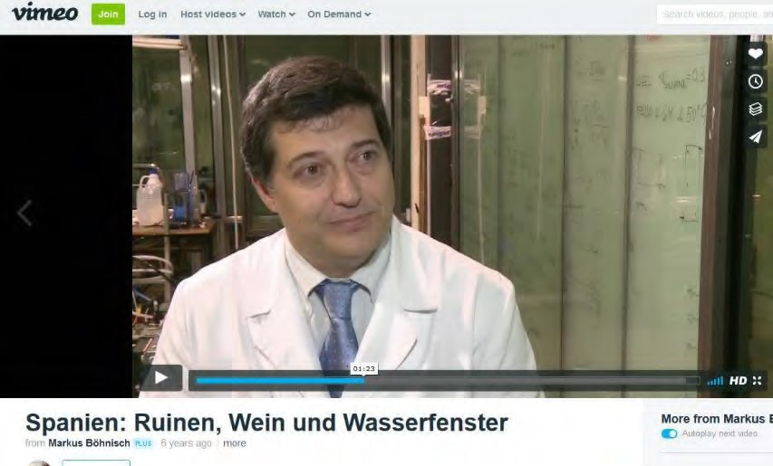

TELEDIARIO TVE 1 http://www.rtve.es/alacarta/videos/telediario/empresas-luchan-contraobsolescencia-programada/1506855/
Interview on spanish national TV about programmed obsolescence and how affects a newly developed product like Intelliglass
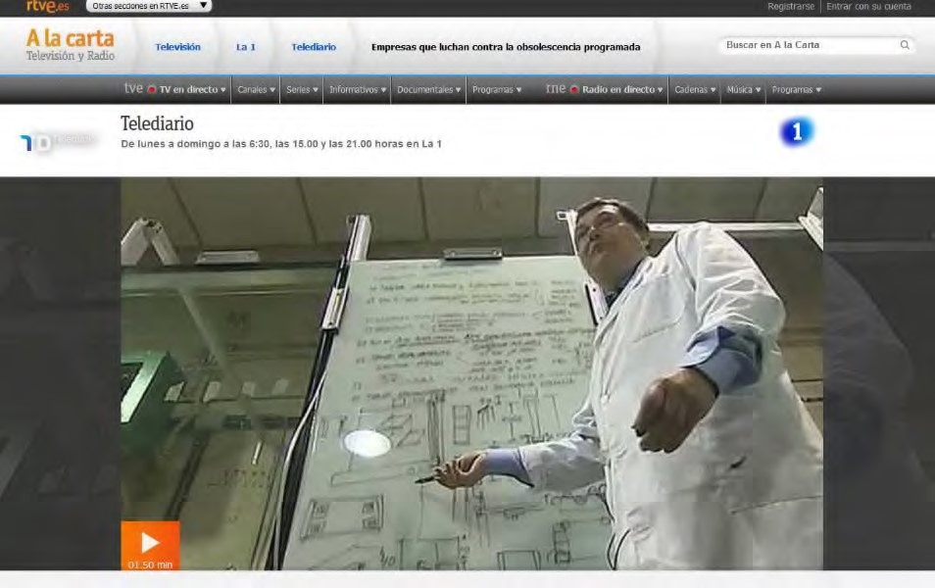
FABRICA DE IDEAS TVE2 http://www.rtve.es/alacarta/videos/fabrica-de-ideas/invierteintelliglass/1086994/
TV special program to explain Intelliglass products strategy.
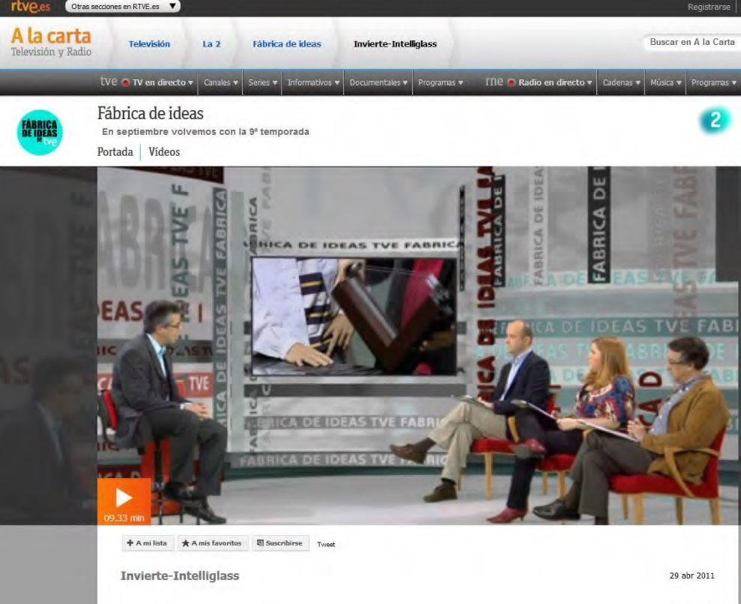

E+I TVE http://www.rtve.es/alacarta/videos/emprendedores-e-innovadores/ei-emprendedoresinnovadores-capitulo-10/1265296/
Chapter 10º of the series Emprendedores + Innovadores (Innovators and Entrepreneurs) by Spain national TV about Intelliglass
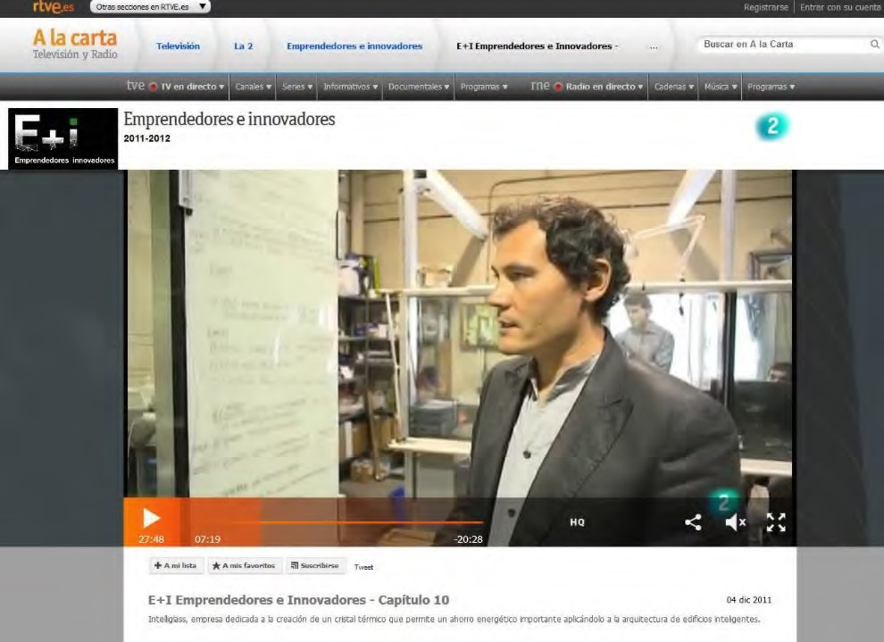
Segre (21/Oct/2019)
News about aircraft storage success at ILD
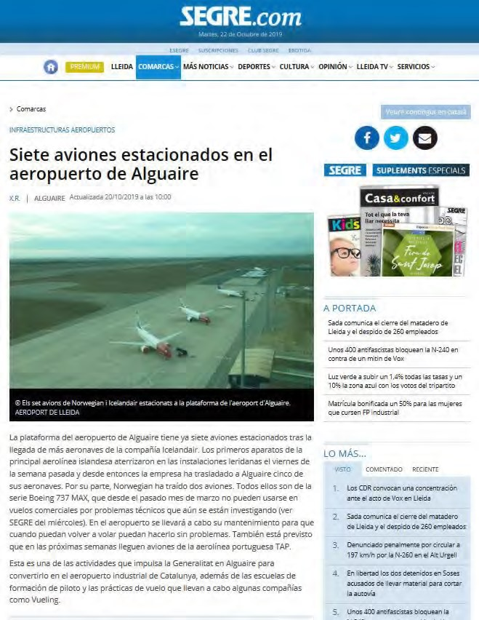
El Economista 18 Junio 2009
Article explaining the Joint Venture de ST Aerospace y de IBERIA to repair Landing Gears
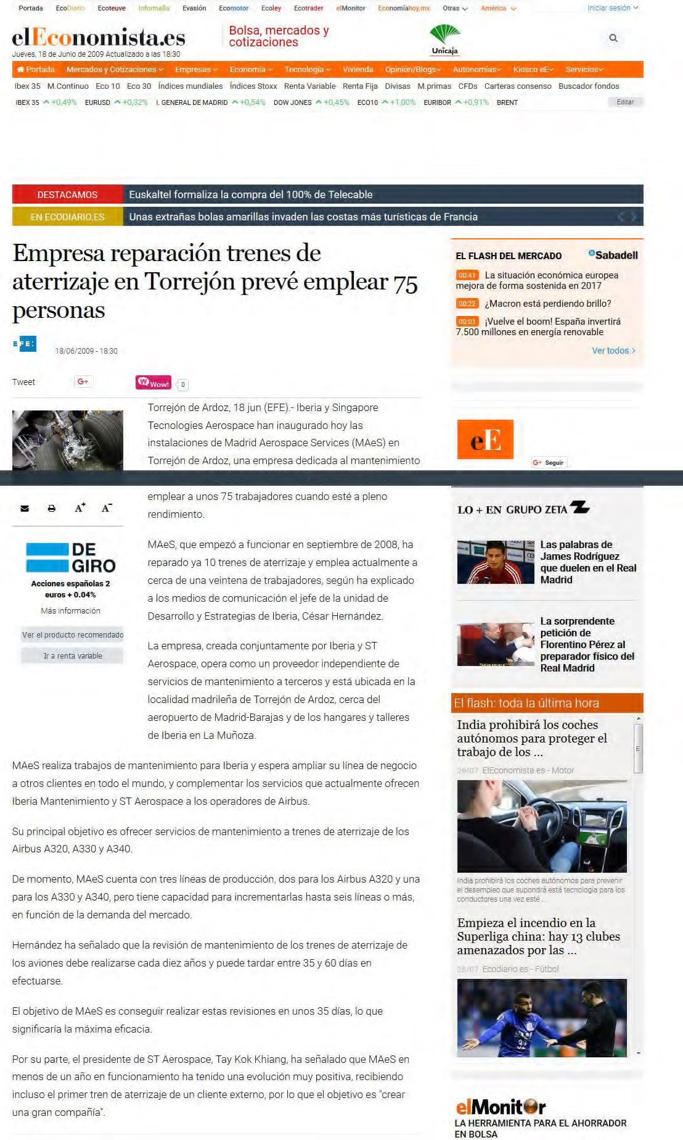
Magazine Todospectrum nº 14 (01/10/1985)
Article “Calculo de estructuras para arquitectos” páges 6 to 10.
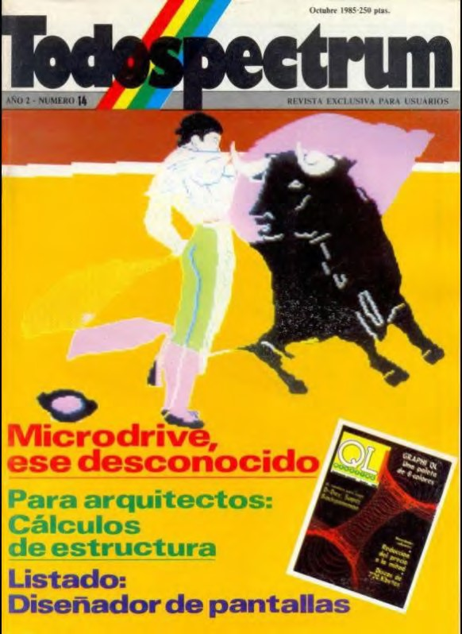
Magazine Todospectrum nº 17 (01/01/1986)
Article “Graficos Interactivos – Dibujando la realidad” pages 6 to 9.
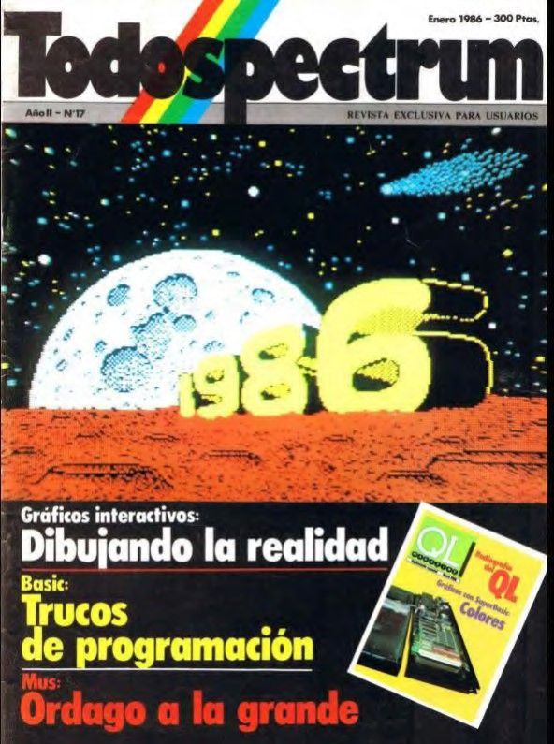
Downloadable at http://microhobby.speccy.cz/zxsf/revistas-ts.htm

INTERNAL COMPANY TRAINING

IBERIA Líneas Aéreas de España

Title |  |  | Date
ISLP Level 1 para gestores (Lean Program) |  |  | 18/11/2016
Human Factors on Aeronautical Maintenance (recurring) |  |  | 07/06/2016
Competitive Laws |  |  | 02/06/2015
General Conduct Code Iberia Group |  |  | 24/10/2014
Cultural Change on Technical Direction Managers presentation |  |  | 14/10/2014
Airport Safety Awareness |  |  | 30/05/2014
Basic Safety Awareness |  |  | 12/05/2014
V2500’ Basic Engine Course |  |  | 17/02/2014
Anti Brivery Legislation |  |  | 12/02/2014
Human Factors on Aeronautical Maintenance (recurring) |  |  | 29/07/2013
Human Factors on Aeronautical Maintenance Part 1 and 2 |  |  | 14/05/2011
Preventive Labour policies. Module 6, Work with screens |  |  | 31/10/2005
Cordiem |  |  | 11/07/2002
Air Transport Course VII Edition |  |  | 04/07/2002
Ariba Buyer |  |  | 08/08/2001
Personal Quality |  |  | 05/09/2002
Airbus ATIS system presentation |  |  | 20/02/1998
FAA Suspected Unapproved Parts (Paris) |  |  | 18/10/1996
A340 basic common Mechanics /Avionics (CFM56) |  |  | 27/09/1996
Procedures and Regulations FAR (Federal Airworthiness Regulations USA) |  |  | 18/07/1996
Basic Avionics Level A MD80 (PW JT8D) Module 3 |  |  | 26/01/1996
Basic Mechanics Level A MD80 (PW JT8D) Module 3 |  |  | 22/12/1995
Basic Mechanics Level A MD80 (PW JT8D) Module 2 |  |  | 15/12/1995
Title Date
Engine Run up A340 (Toulouse) 09/12/1995
Basic Mechanics Level A MD80 (PW JT8D) Module 1 01/12/1995
Básico Avionics B-757 (RR RB211) Module 1 24/11/1995
Line Maintenance A300 Part 1 17/11/1995
Basic Avionics B-757 (RR RB211) Modulo 5 19/10/1995
Basic Avionics B-757 (RR RB211) Module 4 06/10/1995
Basic Avioncs B-757 (RR RB211) Module 3 29/09/1995
Basic Avionics Level A A-320 (CFM56) Module 4 22/09/1995
Basic Avionics B-757 (RR RB211) Module 2 15/09/1995
Basic Avionics Level A A-320 (CFM56) Module 1 08/09/1995
Line Maintenance A340 (CFM56) Avionics complement 04/07/1995
Line Maintenance AIRBUS A340 Level II, Theory 30/06/1995
Line Maintenance AIRBUS A340 Module 2 30/06/1995
Line Maintenance AIRBUS A340 Module 1 23/06/1995
ACARS Introduction 10/05/1995
Health and Safety for managers 08/02/1995
A320 Familiarization for M.S. Engineers 16/02/1990 MD87 Familiarization for M.S. Engineers 28/10/1988

Training as instructor
MATS II & GCF 1999
Line Station support in MATS II 1998
KITS in MATS II for store men 1996
Stock management for OPC technicians (planners) 1990

THE BOEING COMPANY
January 1987 – August 1988
Seattle, Washington USA
Course |  |  |  | Year
Airline Marketing (Don Bennet) |  |  |  | 1988
Introduction to Quality Improvement (Dr. Juran) |  |  |  | 1987
Statistical Process Control |  |  |  | 1987
Quality Control (Edward Deming) |  |  |  | 1987
Fourier transformation on structural calculus (MIT) |  |  |  | 1987

PROFESIONAL COLLEGES

Aeronautical Engineer of the Aeronautical Engineers National College with number 3.883
Member of the Society of Allied Weight Engineers (SAWE) while working at Boeing

P
ATENTS

Spanish Patent ES 280471 ES1. European Patent EP 2123856A1. USA Patent 8341894B2

INTERNATIONAL AND NATIONAL COMMITTEES

TEDAE: Spanish association of Space, Defense, Aeronautical Technologies Companies
Representing IBERIA. Permanent Member of Management Committee until Iberia left (2010-2014)
ATECMA. Spanish Association of Aeronautical Materials Constructors.
Representing IBERIA until the closure of ATECMA and incorporation of TEDAE (2007-2010) ASD. European Association for Defense.
Task Force Member of Aeronautical Maintenance and sub task Technical English. (2010-2014)
AEA. Airlines of Europe Association.
Member of Materials Purchasing and Planning committee. (1989-1999
ATA. Airline Association of America.
Member of Spec 2000 Coordination Committee (1990-1999)
Member of Task Force that developed “Repair Order Administration” Chapter 7) (1993)
Member of Task Force that developed “Initial provisioning R-File Chapter 1) (1991)
ALTA. Latin America Airlines Association
Member of CCMA, Comité de Compradores de Material Aeronáutico (1997-2015)
Participant at AITAL – Technical Committee. (2013-2014)
IATP. International Airlines Technical Pool
Iberia Senior Delegate. (1996-1999) One World. Airline Alliance oMEG representative (2000-2008)
PMA Task Force Chairman (2002-2006)
Exec. VP Assistant to the meetings of Technical Executive Committee.(2006-2008)
IAWA. International Airlines Warranties Association
Committee member. (1996-1998)
BAIE. Catalan association of aerospace companies
Representing Iberia. (2010-2014)

CONFERENCES

ENTERPRISE IRELAND. Irish public company to encourage export business of Ireland and foreign investments. During Av. Week MRO 2013 in Madrid, I worked to support them organizing a meeting with a lunch between the Ambassador of Ireland to Spain, several CEO’s of the main Spanish and Irish industries. (2013)
ACPC. Air Carriers Purchasing Conference. Representing Iberia in 18 conferences (1991-2014), being panelist in few of them.
AVIATION WEEK MRO. “Aviation Week” organize expositions and conferences having attended most of them, being speaker, panelist and exhibitor. (1991-2015)
AIRLINE E&M Conferences. Maintenance and Engineering conference to divulge profesional aspects to help develop contacts networks in the industry. I have been speaker and panelist is several occasions presenting “ E-business Spec2000”, “Initial Provisioning management with Chapter 1”, “ Repair Order Administration, Chapter 7”, “PMA’s”
SPEC2000 FORUM. Conference organized by ATA to promote the use of Spec 2000 to perform electronic business on aerospace materials and services. This specification allow the conexion computer to computer using the telegraphic network (1970’s) In this meetings I presented real cases of use of Spec 2000 inside the MATS II system as well as new developments of the working groups I was a task force member. 1991-2005
GORHAM PMA PARTS & DER REPAIRS. MARPA, is the association of PMA manufacturers (non orginal Spares under authorization of the FAA) and DER repairs.This company organize yearly meetings in which they invite industry companies to present their cases. I did present 4 times the Task Force PMA on Oneworld and explain the policies to embrace PMA’s on Iberia and the OneWorld alliance (2002 a 2006). Before that I was the Iberia representative as panelist (1996-2001).
PARIS AIR SHOW. Bi anual Exposition of the aerospace industries with the participation of all companies. I have participated as exhibitor on the spanish Pavillion in 2013-2011-2009 y 2007.
IIR Spain, Instructor for the course “Subcontracting Services” in 2003 and 2004. Training was held in Madrid and Barcelona.
Marcus Evans Conferences. In 2007 I was invited to present “Outsourcing Services” in Barcelona.
CCMA. Comité de Compras de Material Aeronáutico de America Latina. In this conferencias I made several presentations of the work developed by AEA and helped to coordinate efforts in these 2 committees. (1997-2015)
AEA. European Airlines Association. Material Planning and Purchasing Committee arranged a yearly conference in which companies presented success cases, improvement programs, electronic business, information sharing. In 2001 AEA decided to pass this organization to Aviation Week MRO (1989-2000)
ADM SEVILLA 2012. Aerospace Defense Meeting in Seville. I presented the conference “Future isn’t what it was” in front of the plenary. I presented the case, as operator, of the lack of support to operators to allow in house maintenance. This was the beginning of today’s monopolistic behavior (2012)
LLUIS BUSINESS SCHOOL. LLUIS GUIDO CARLO UNIVERSITY ROMA. In 2012 I was invited by Lluis Business School to present a case for the Master on Aeronautical Business Administration. IAG did not allow me to present this case due to a Confidentiality Agreement.

A
NEXE
S

Title of Aeronautical Engineer:

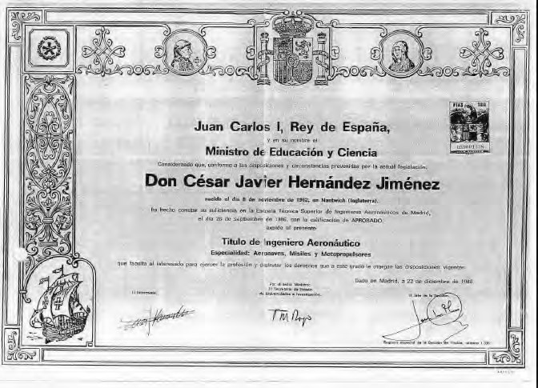

Title Euroforum Strategic Leadership

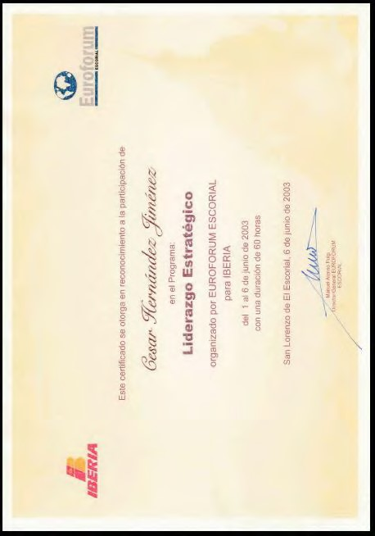

Title IESE Corporate Finances

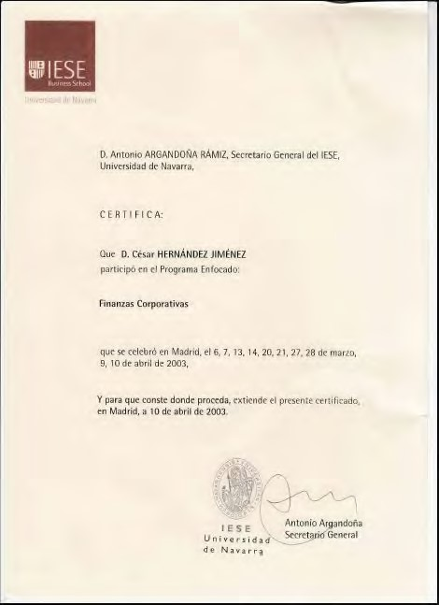

Award Actúa UPM 2007
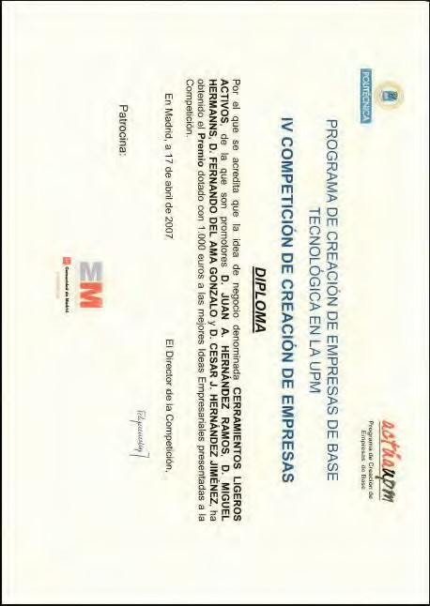

Award Madri+d 2007

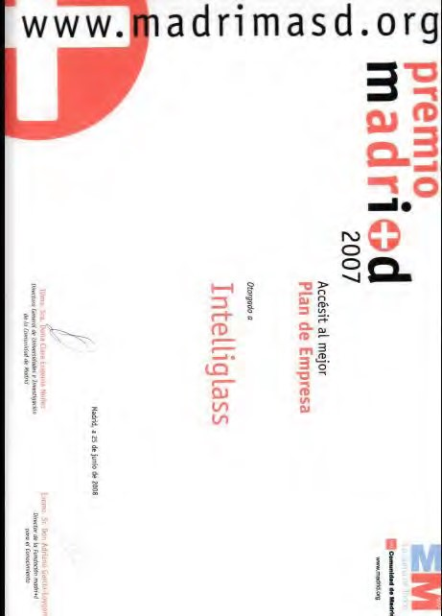

Finalist Eurecan, European Venture Contest

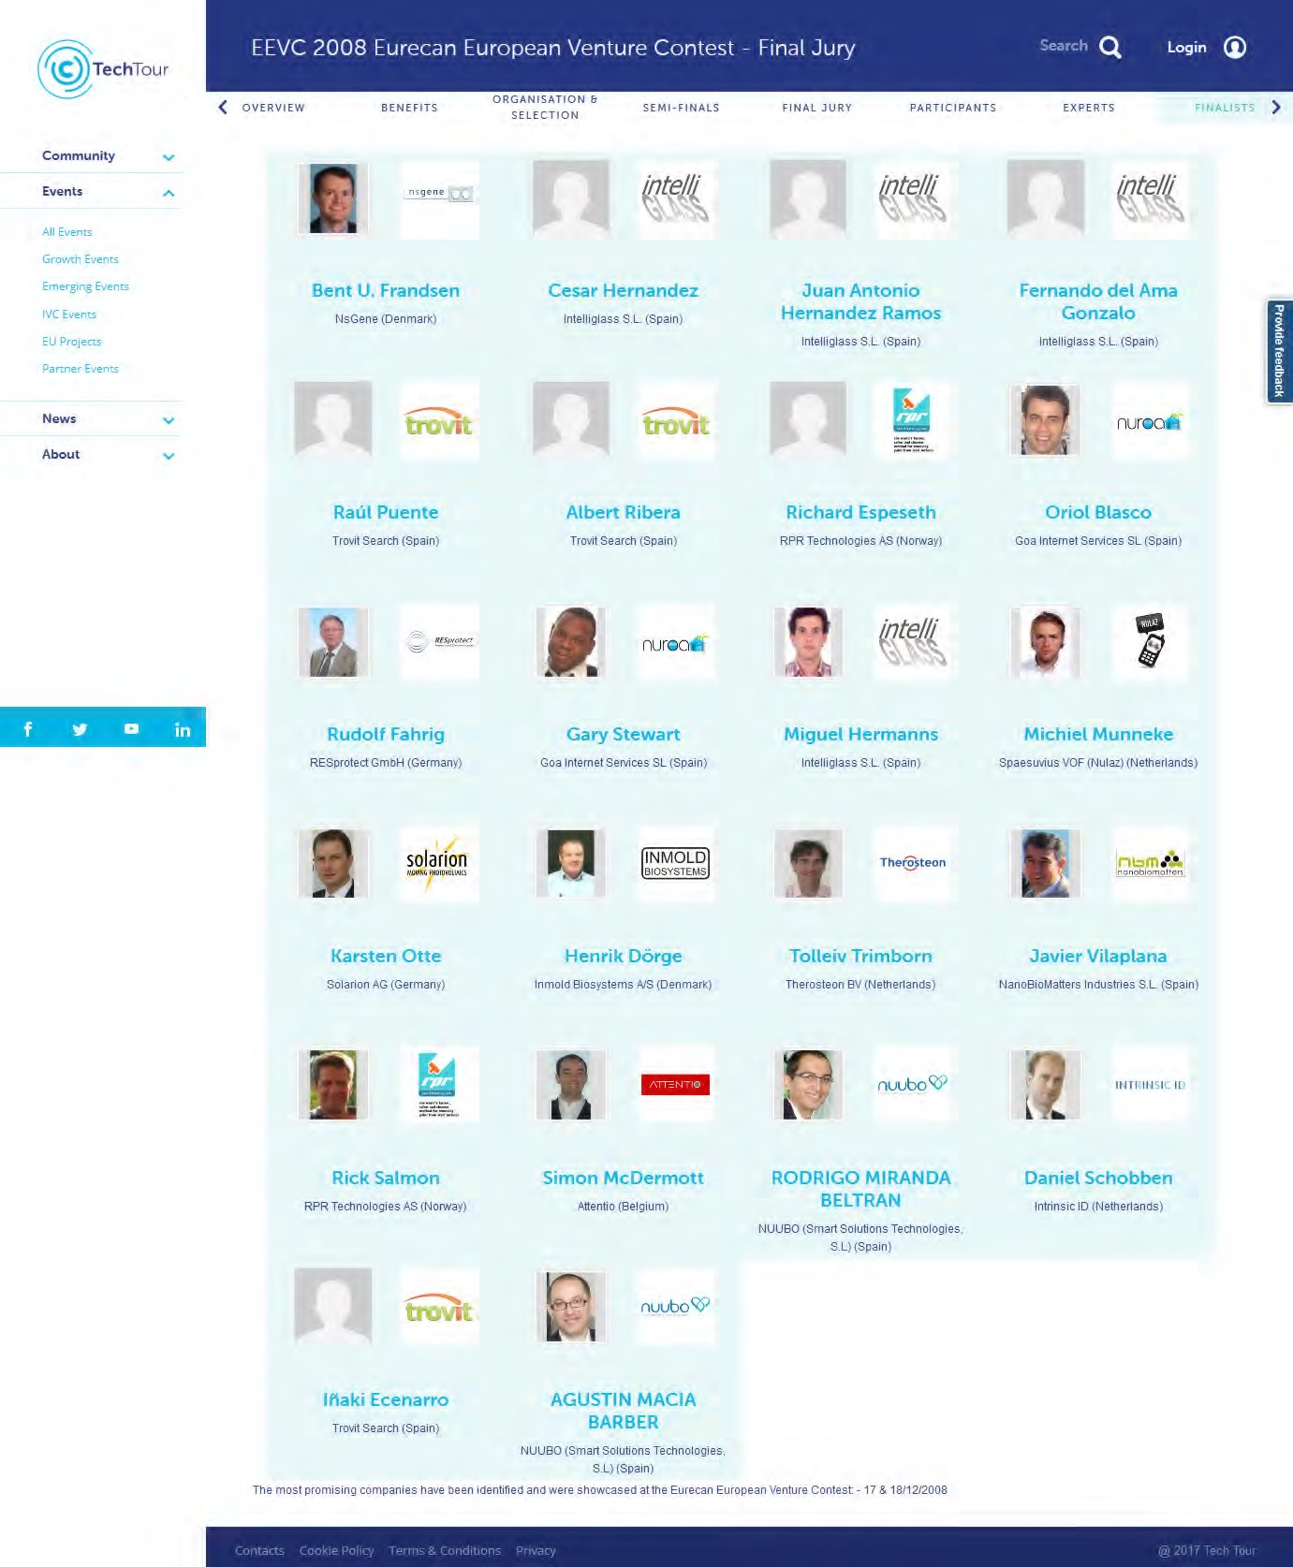

Finalist Madrid Network Challenge 2010

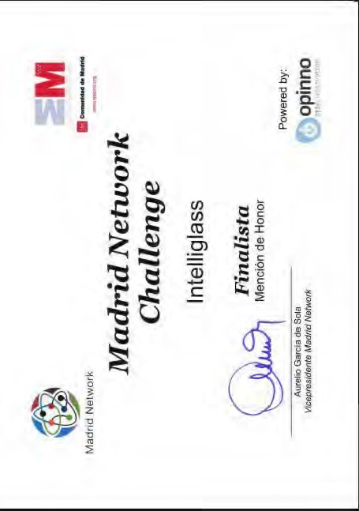

Internal training Certificates
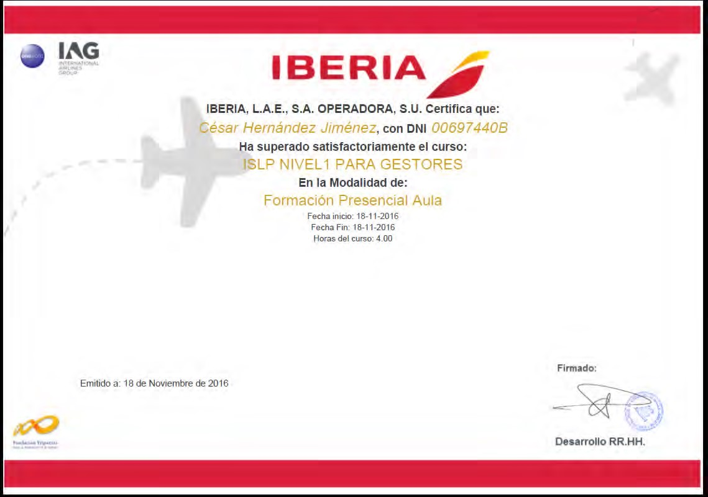
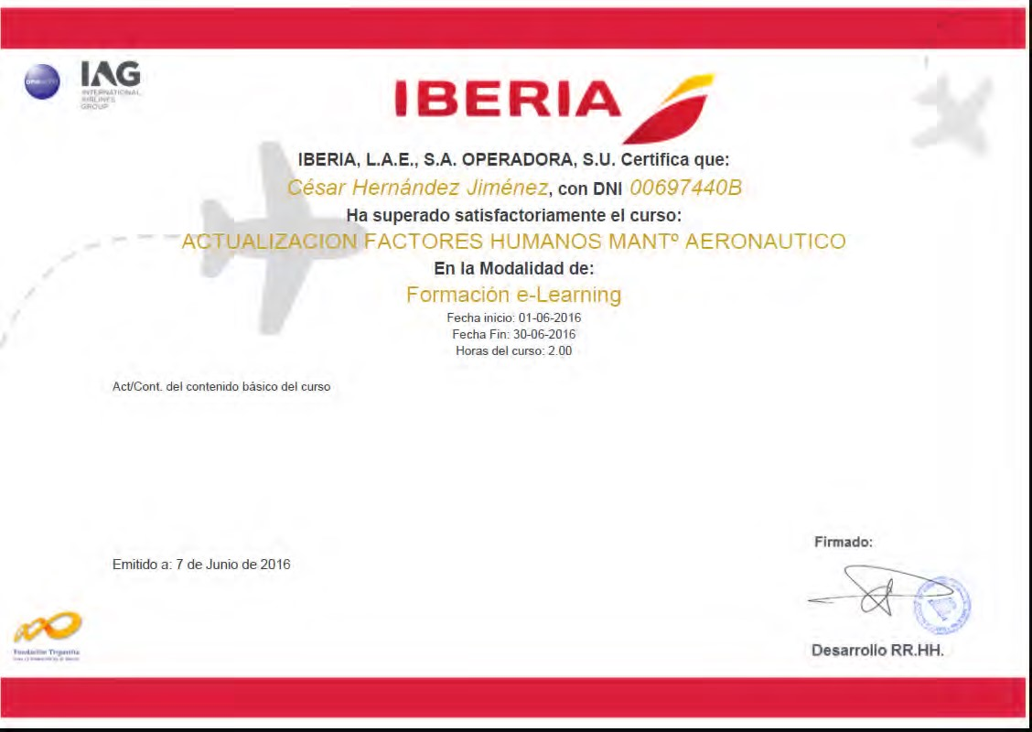

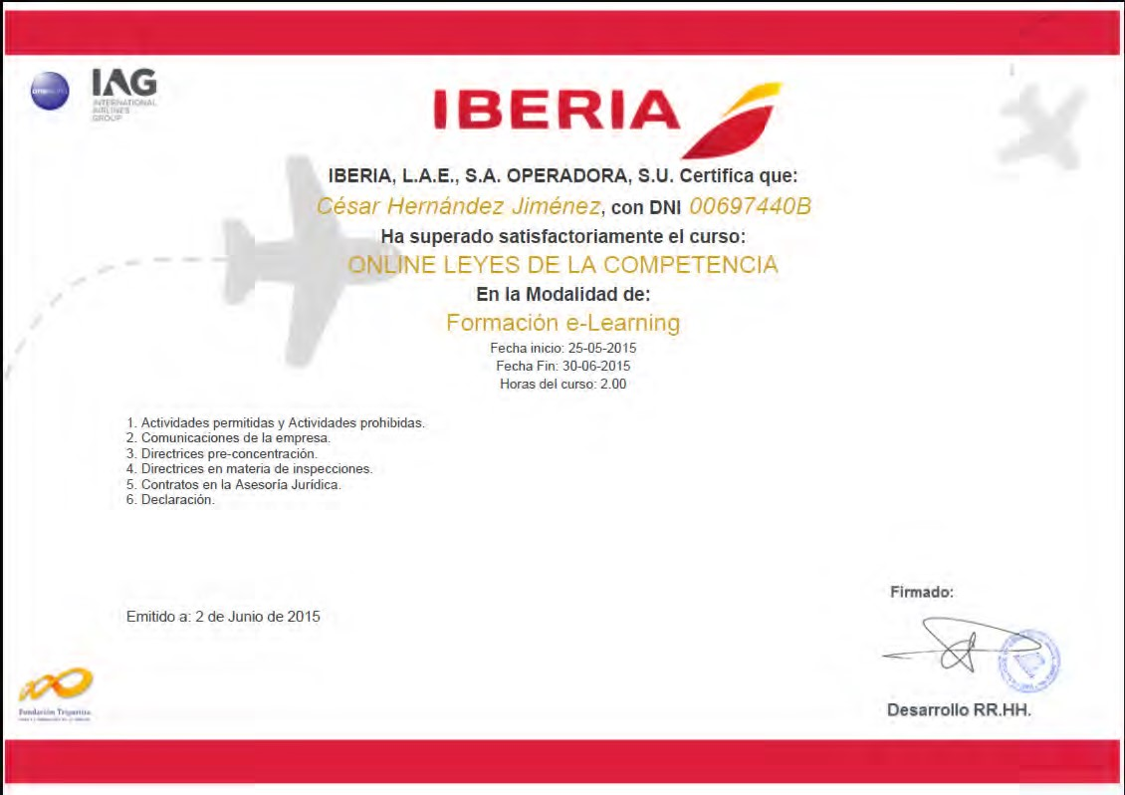
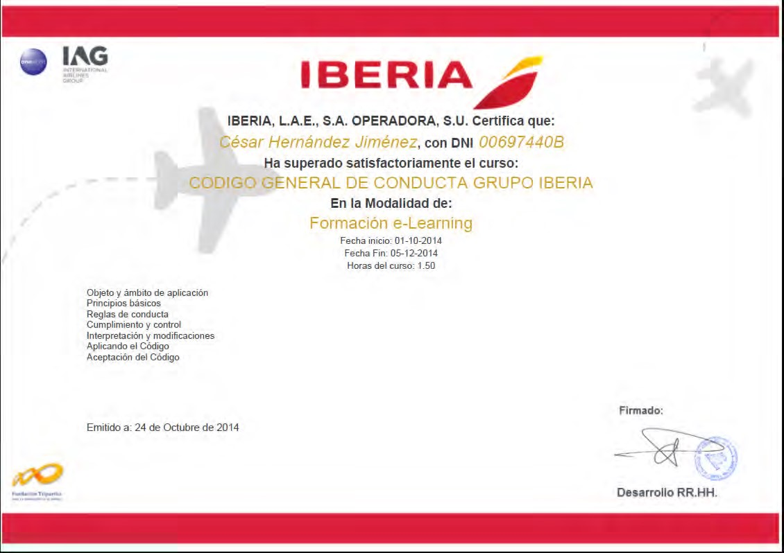
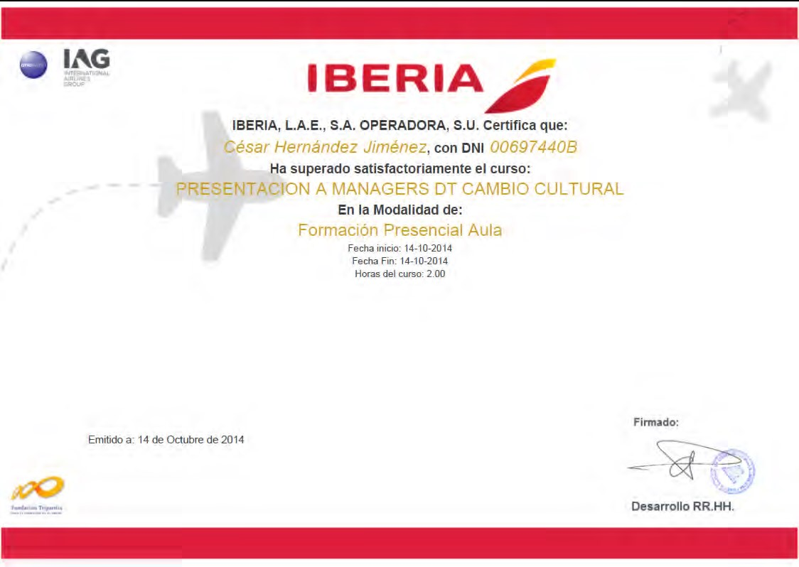
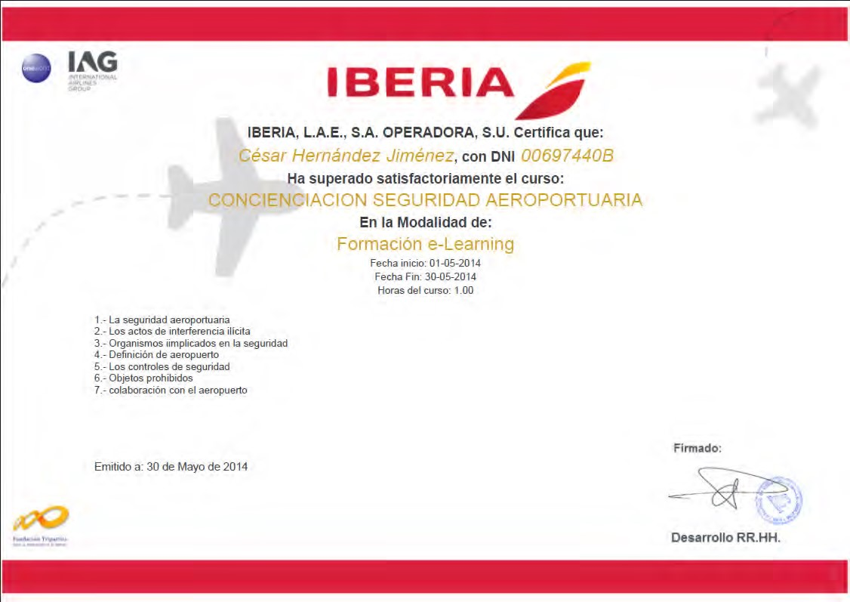

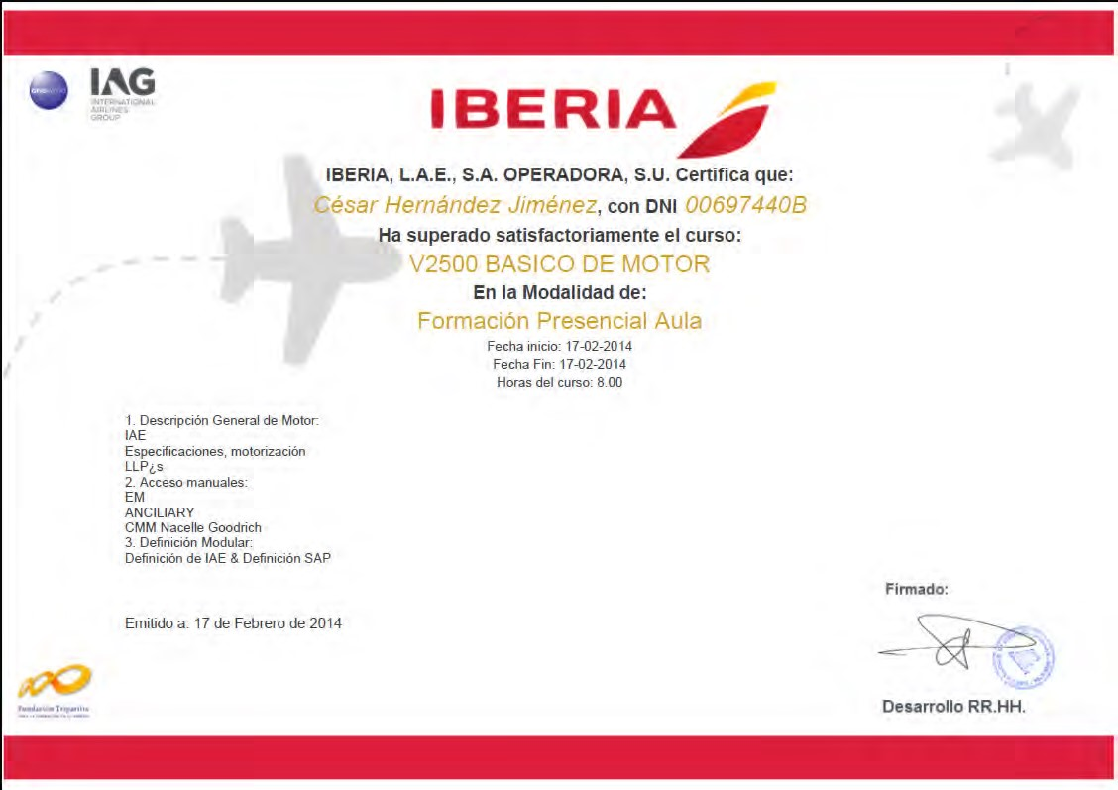
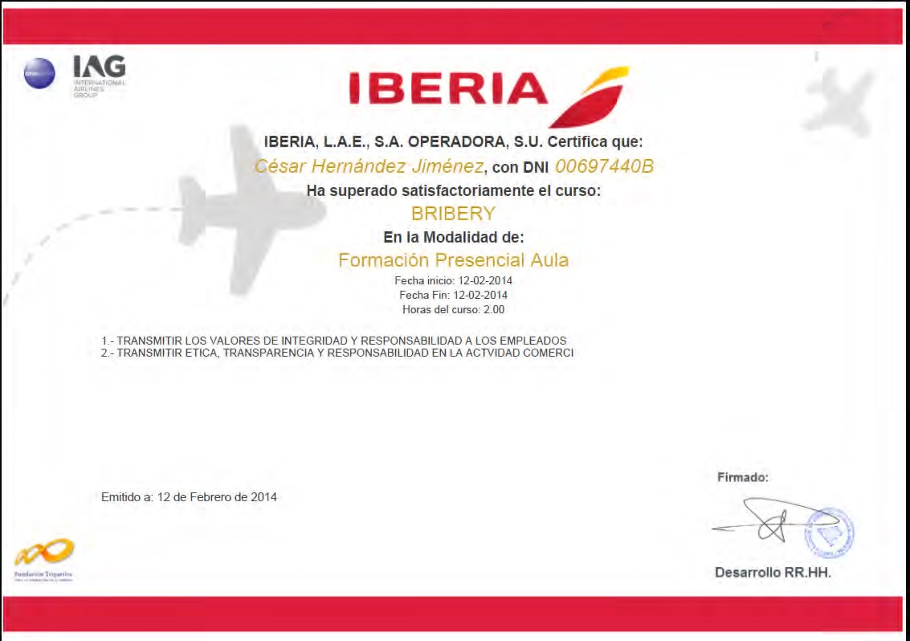
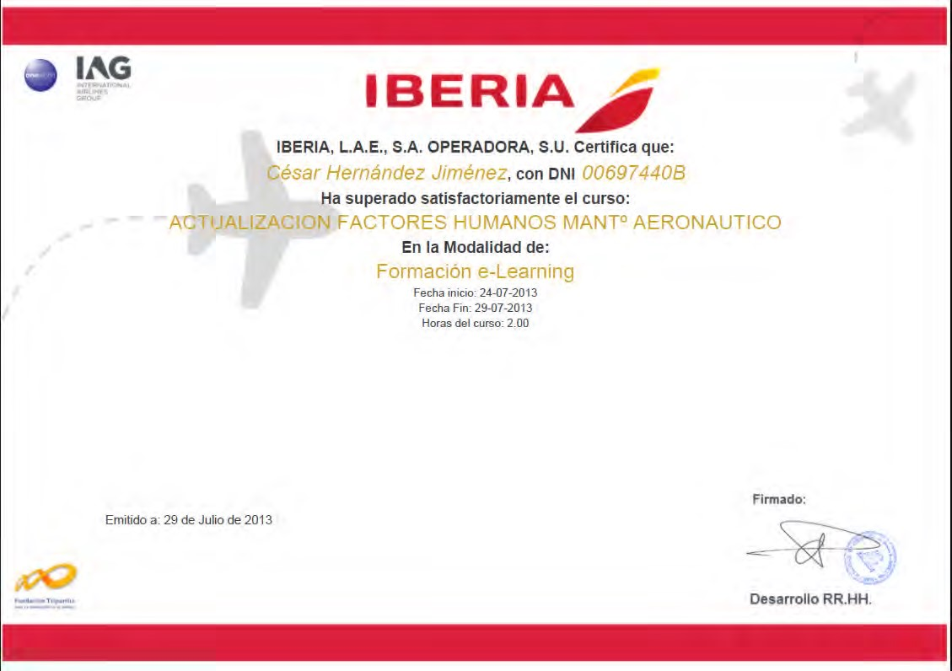
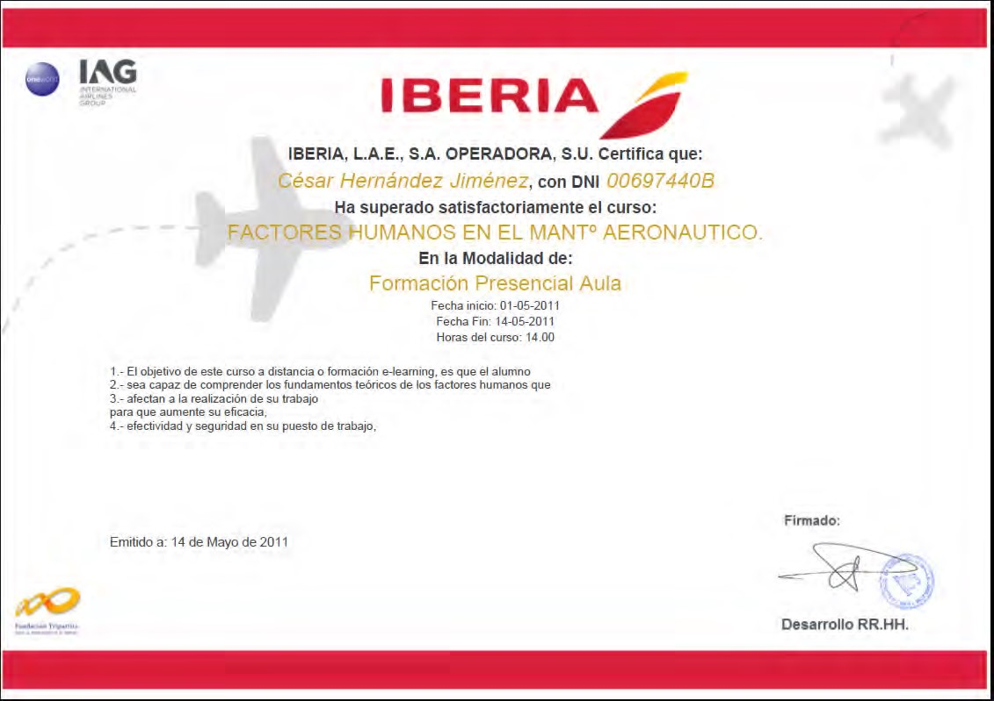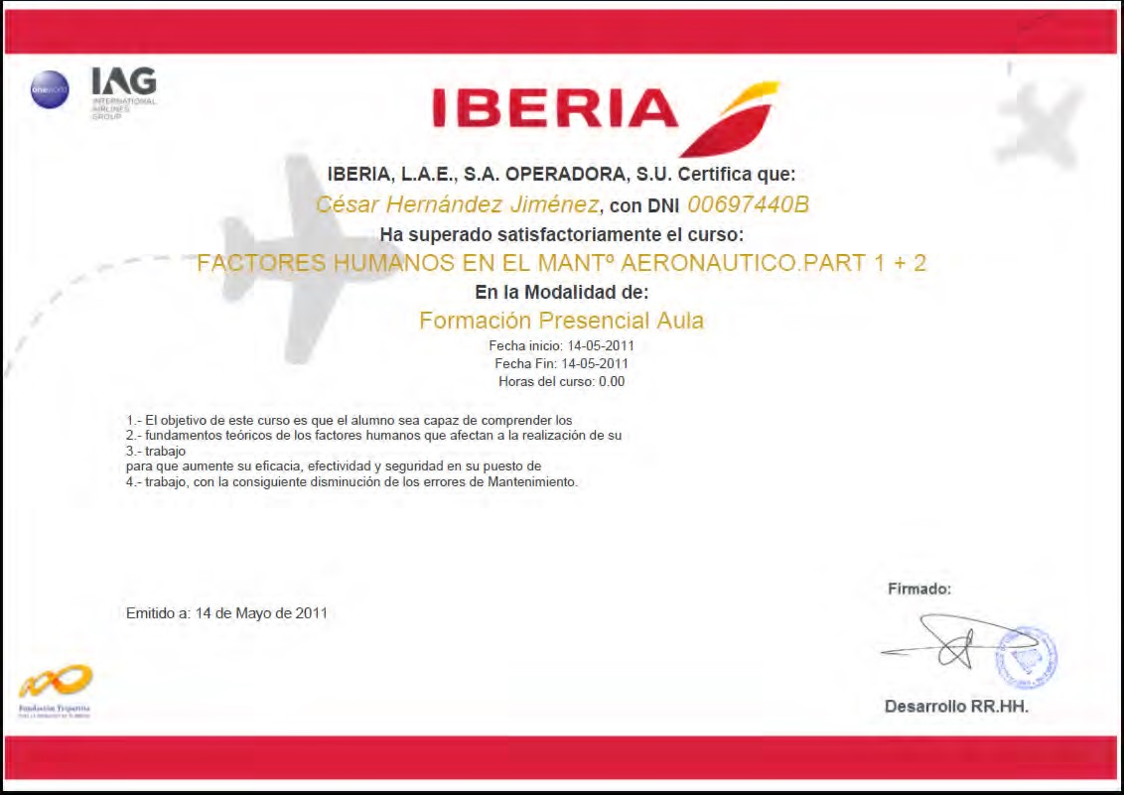
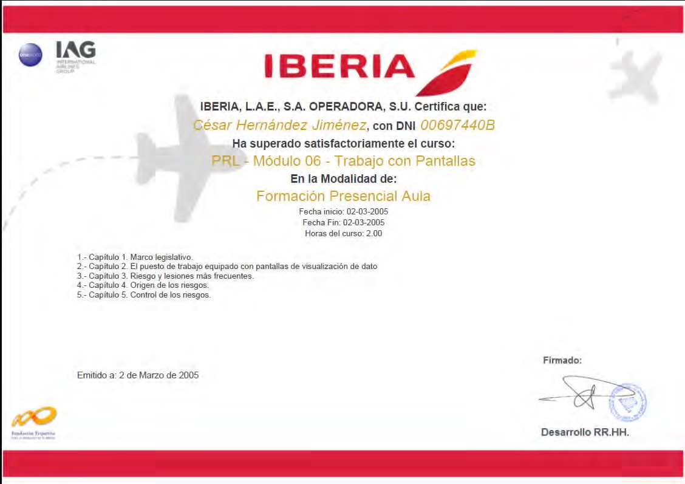
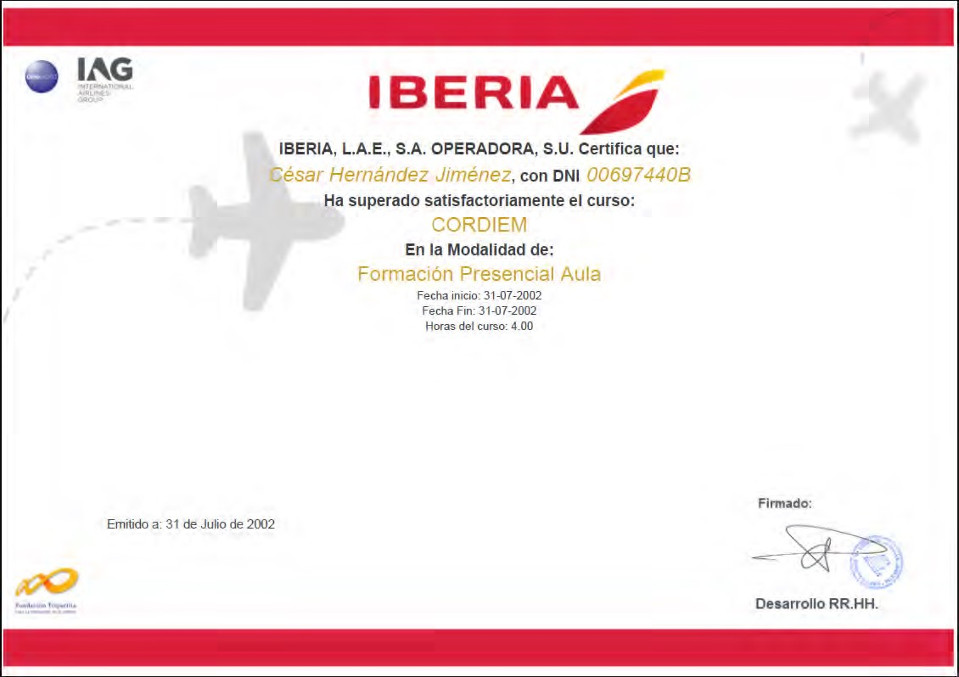
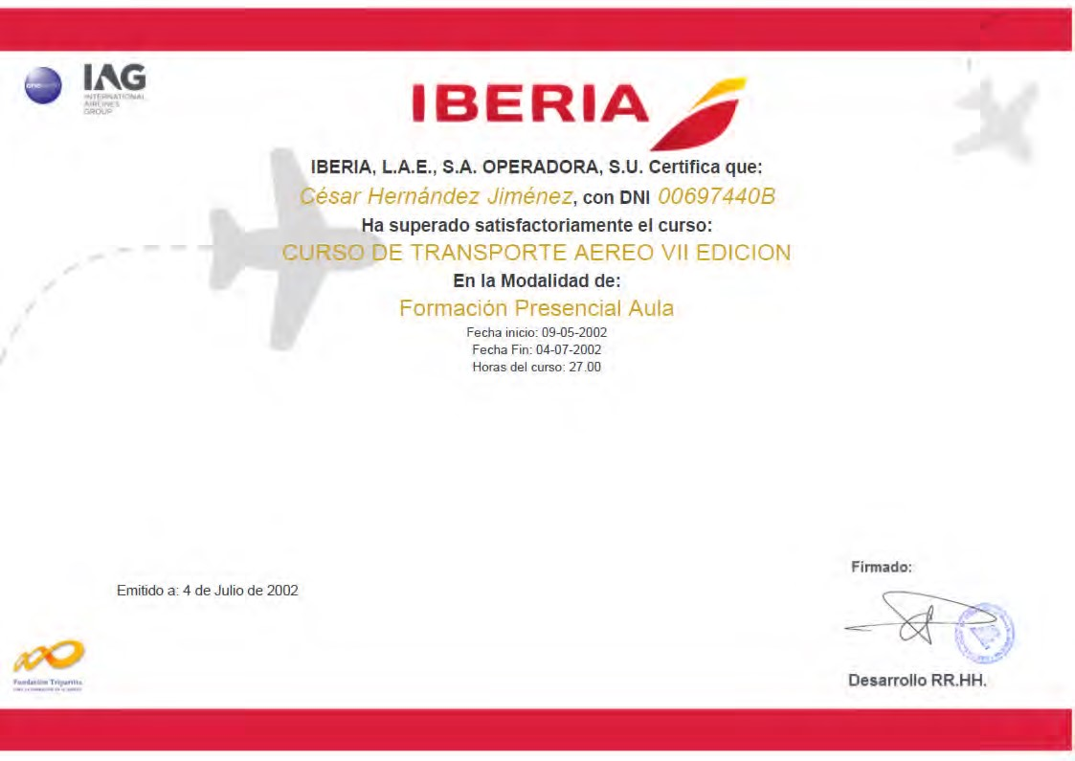
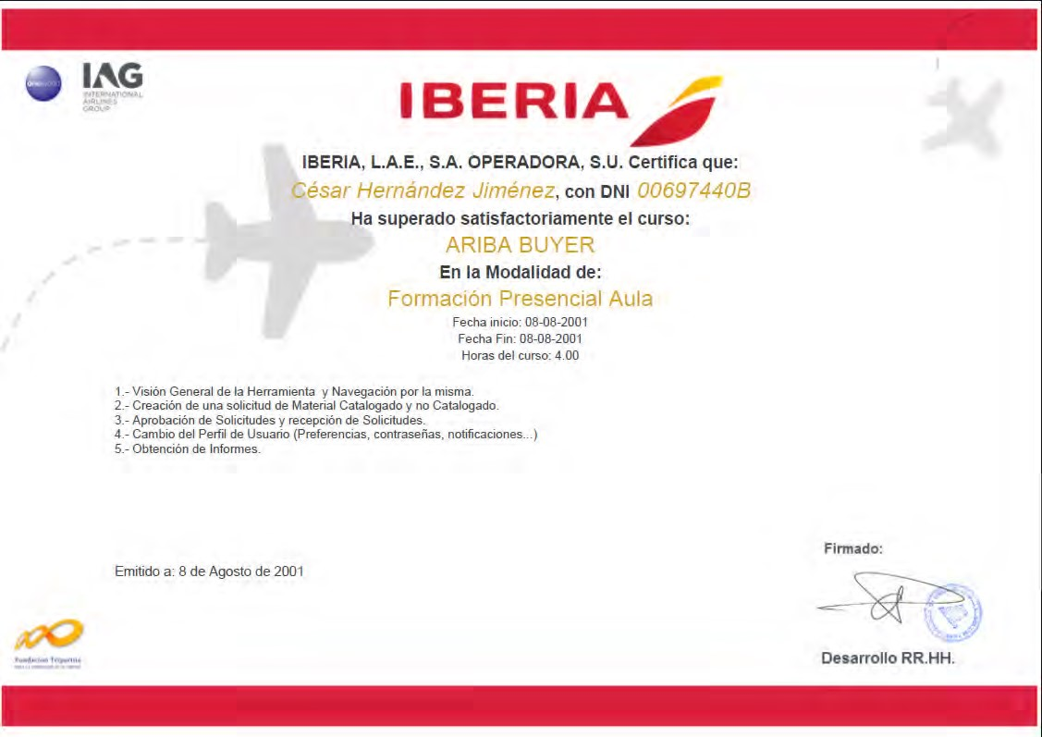
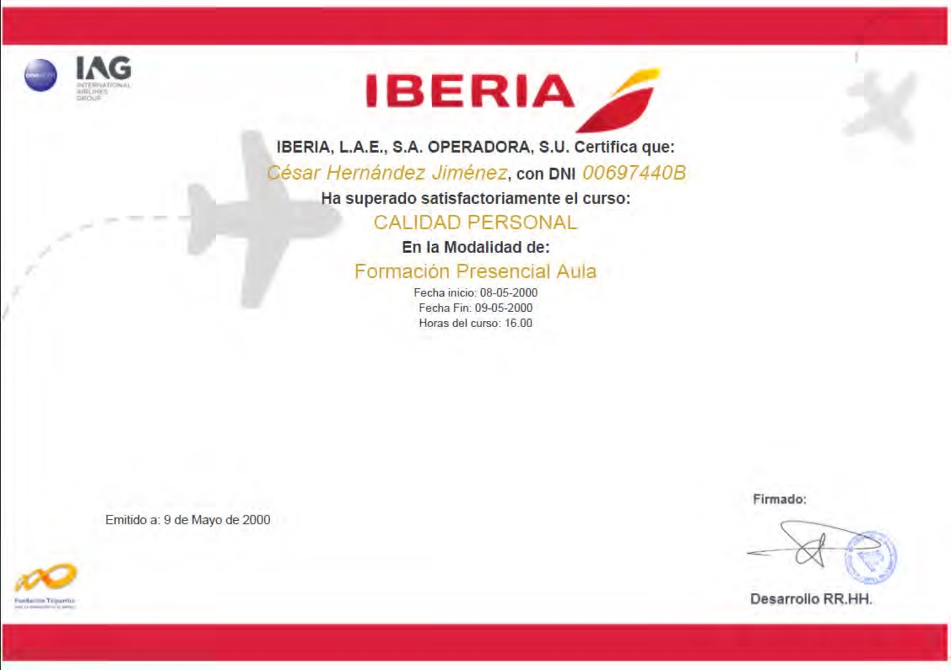
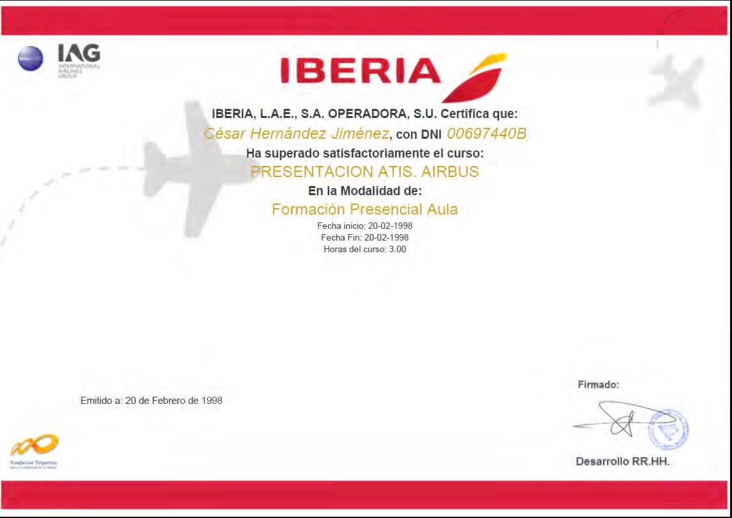
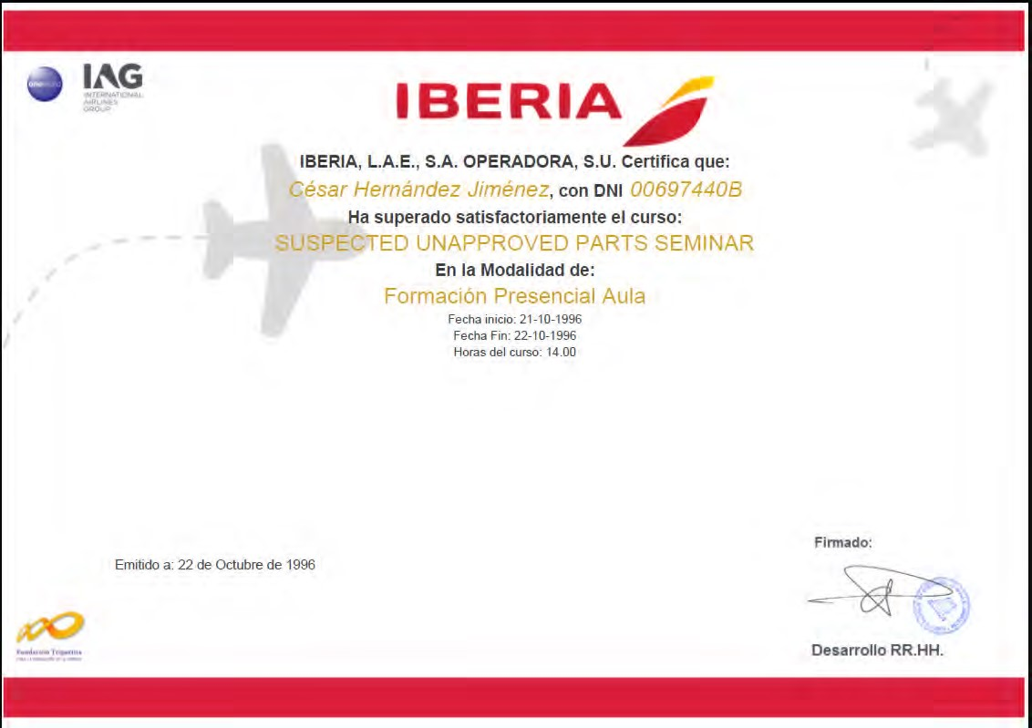
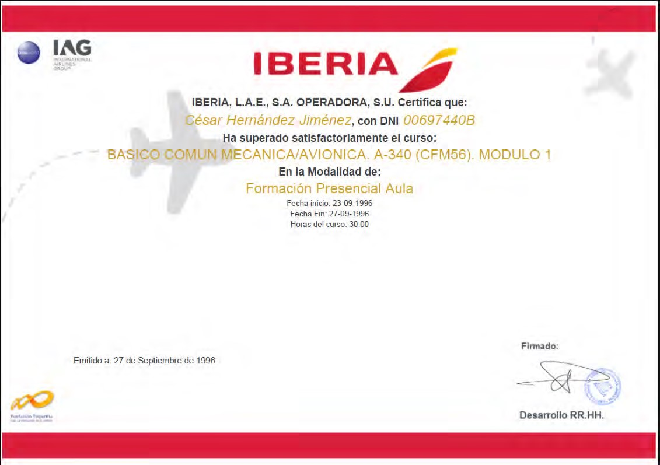
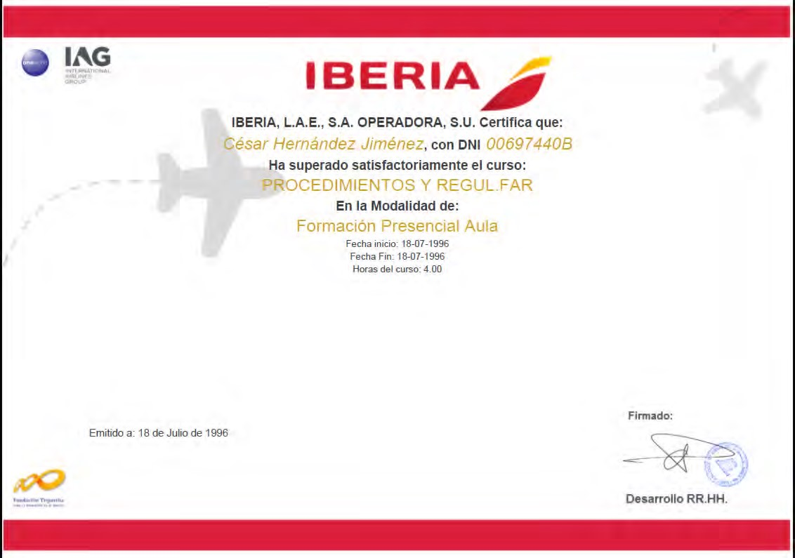
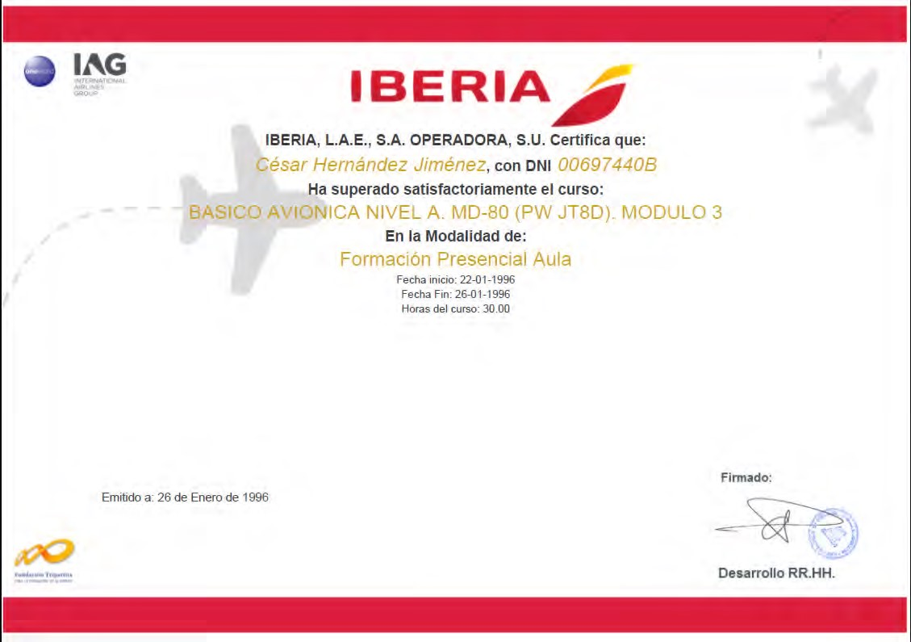
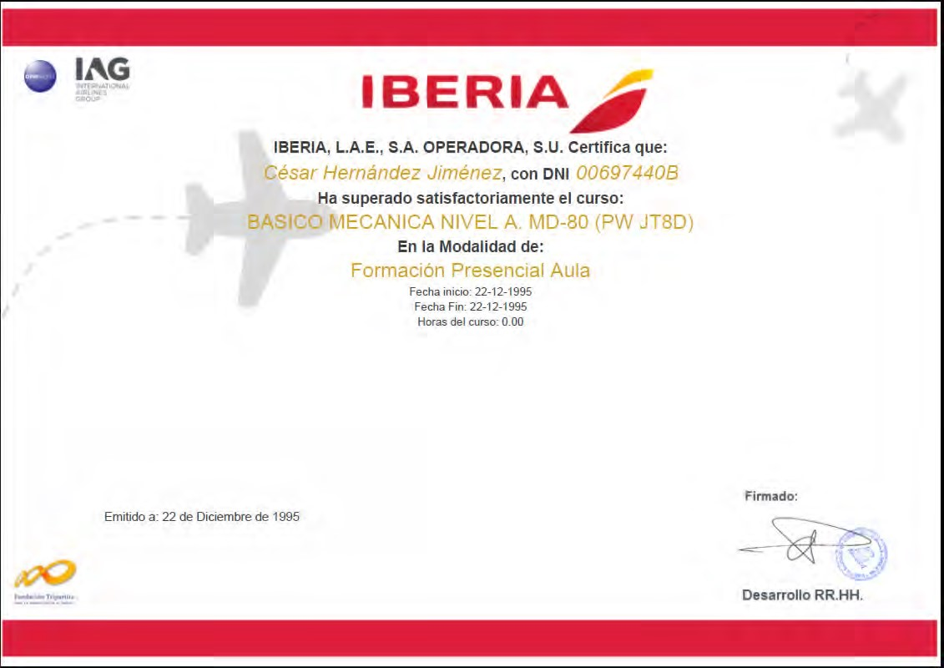
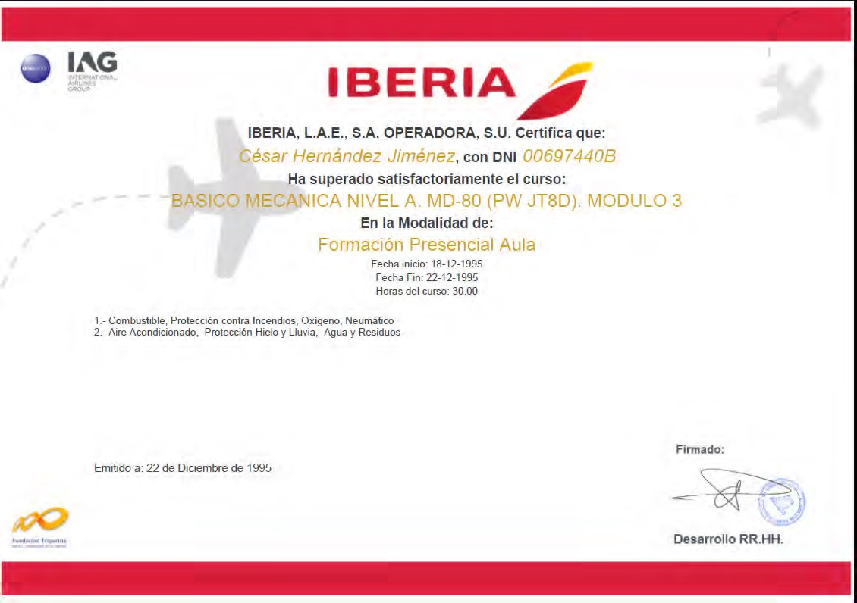
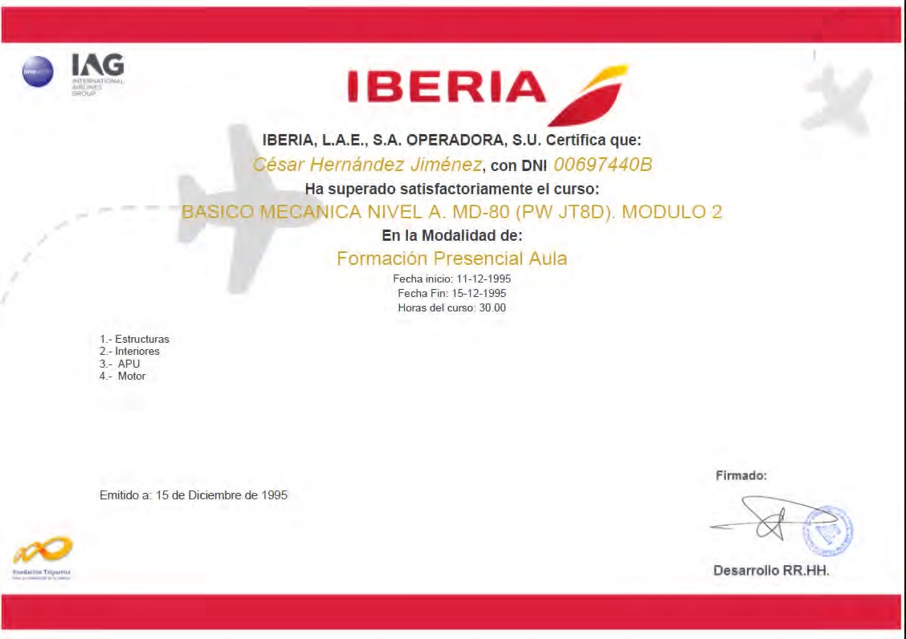
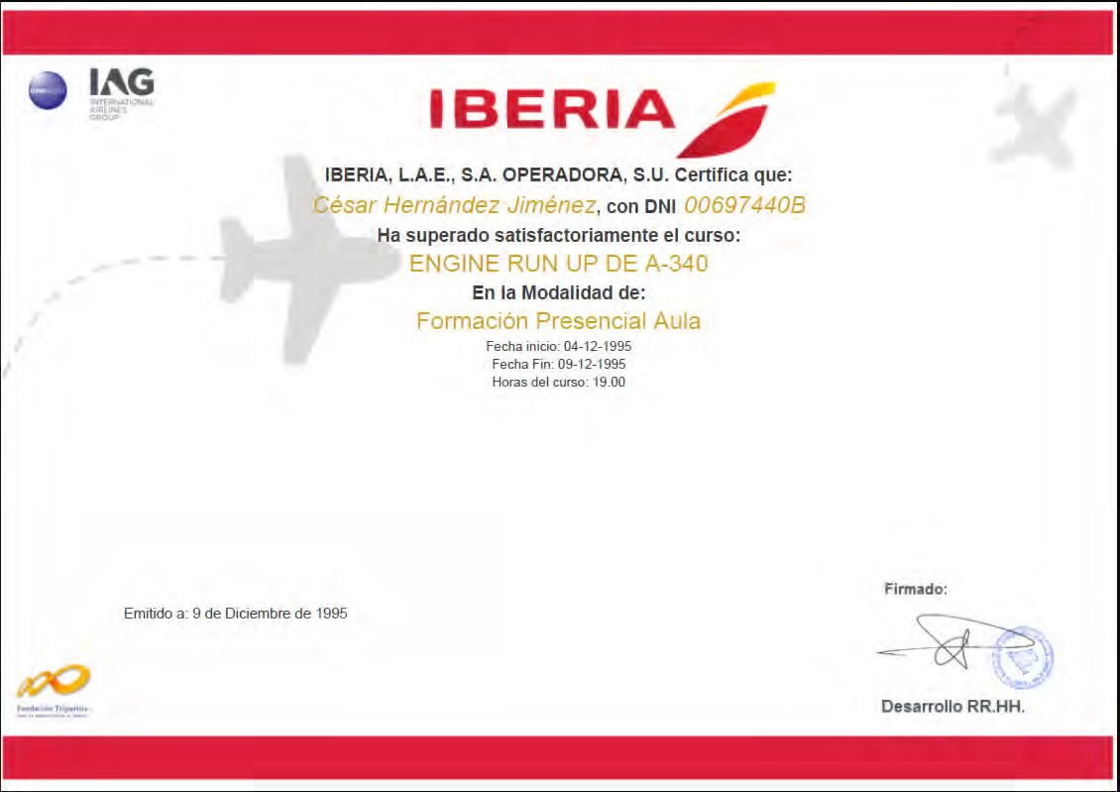
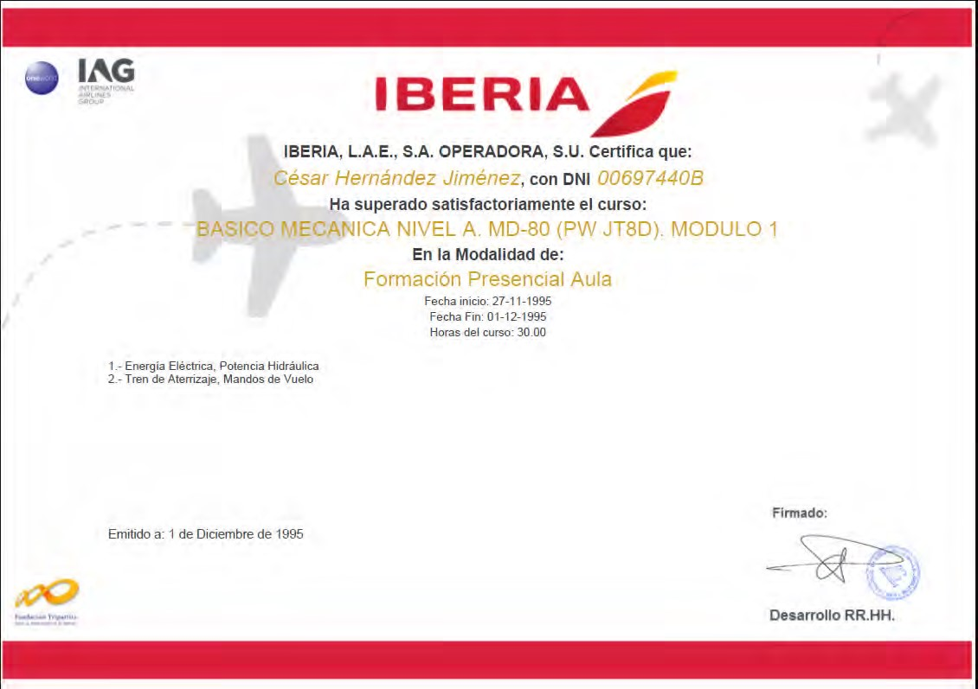
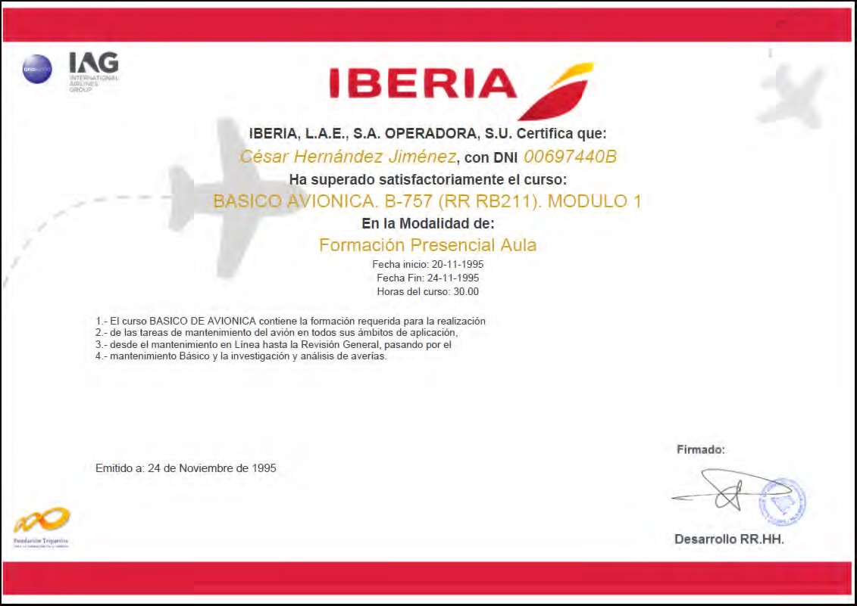
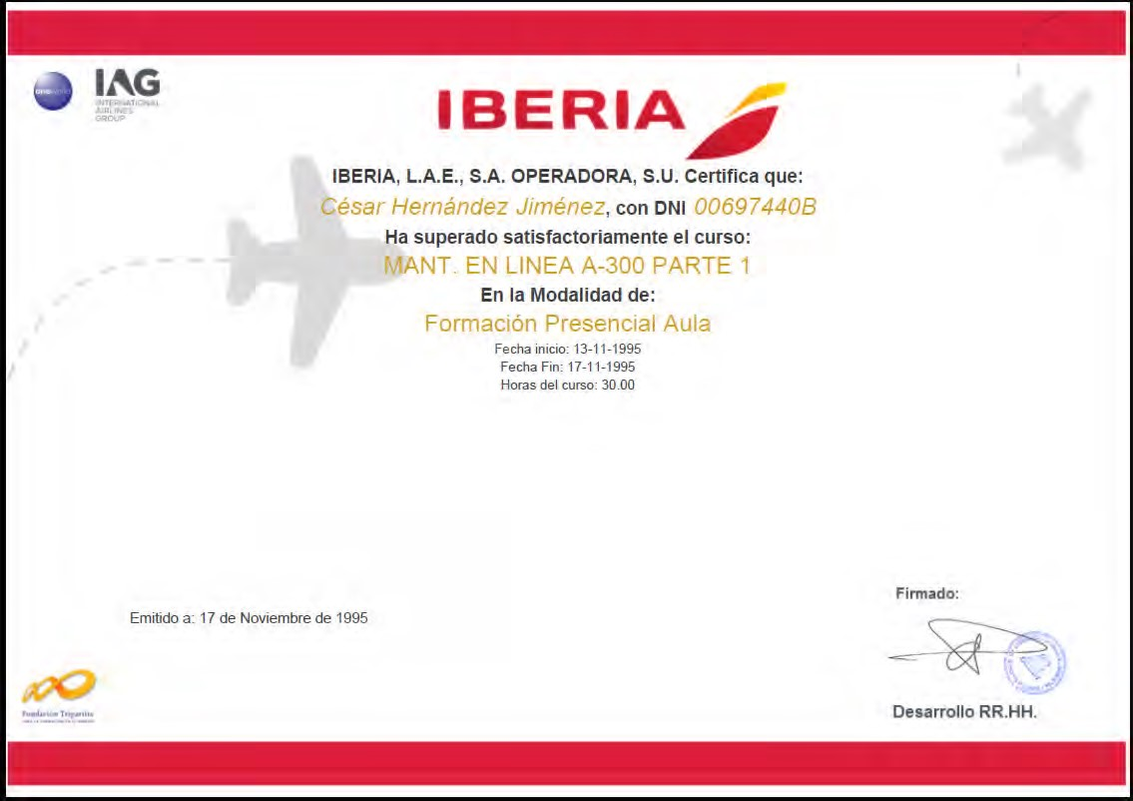
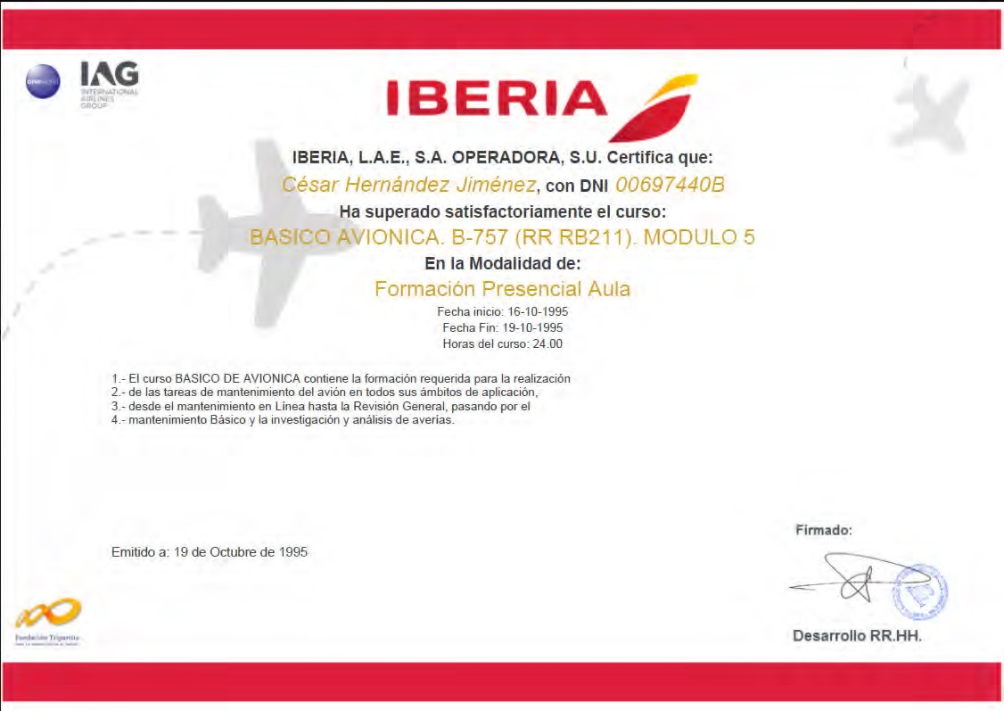
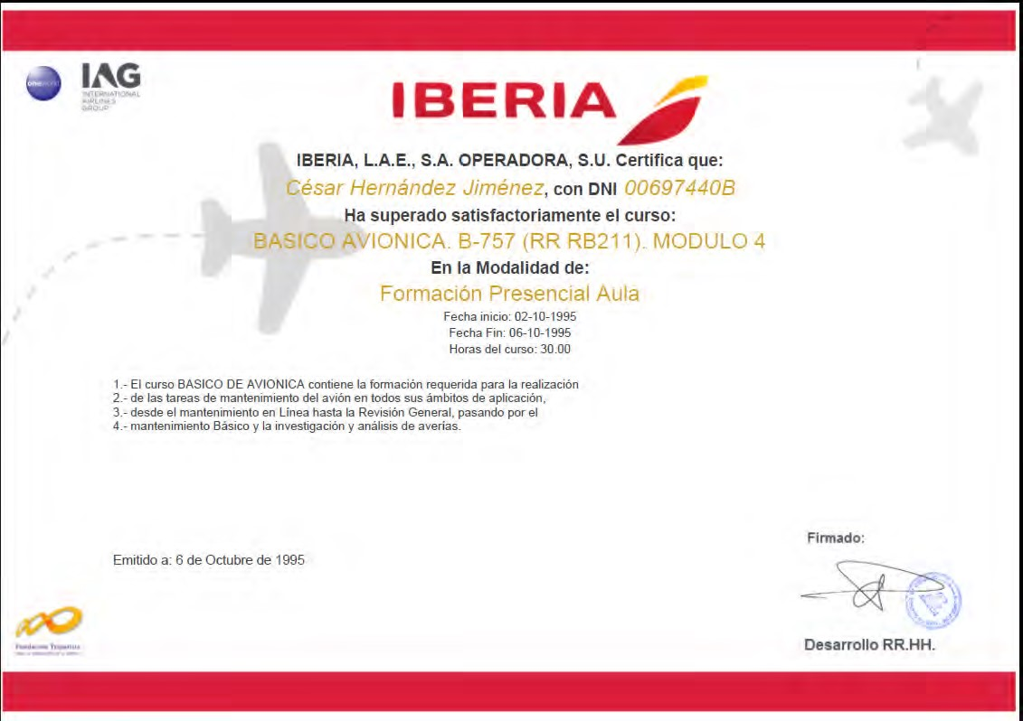
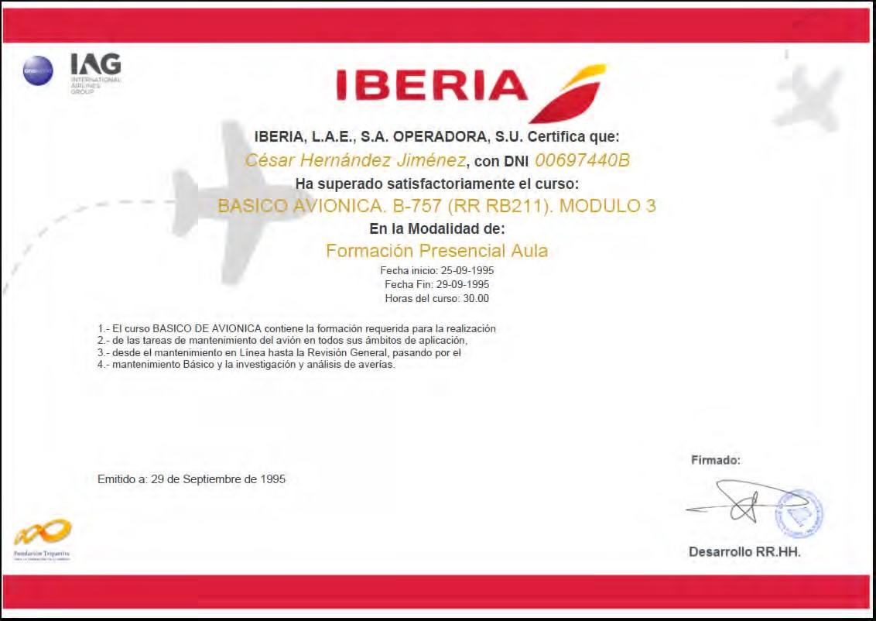
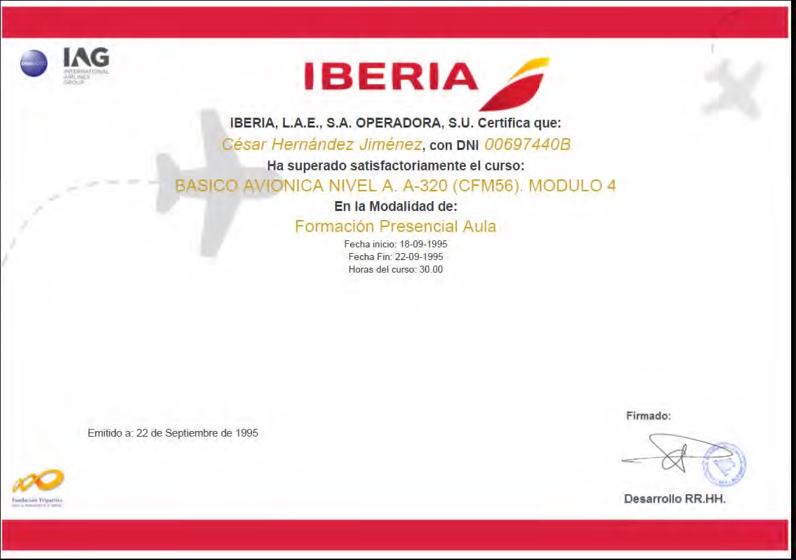
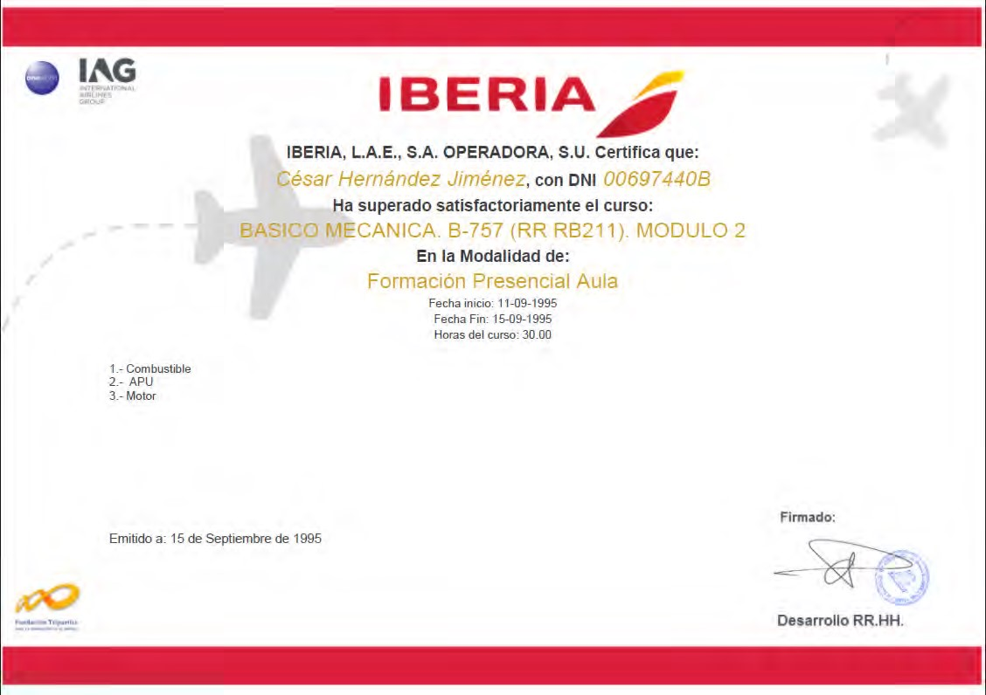
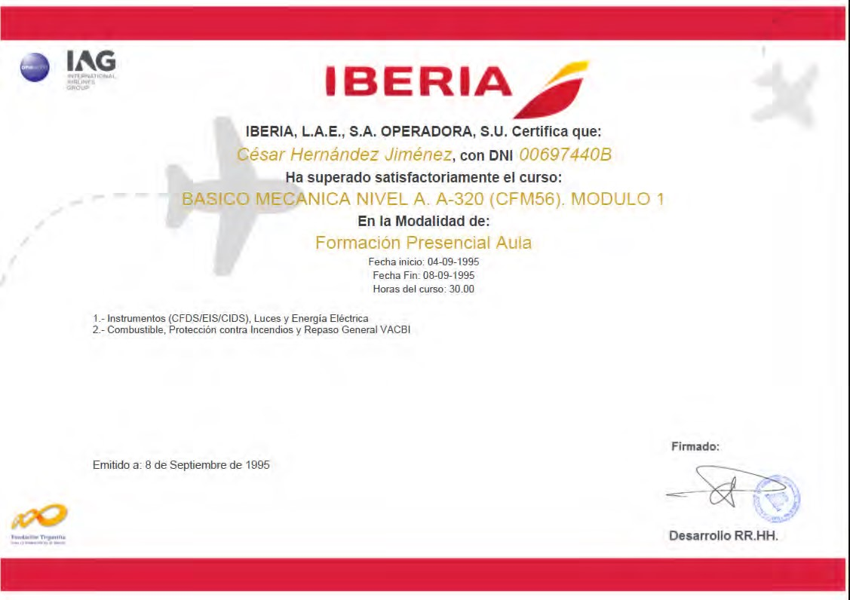
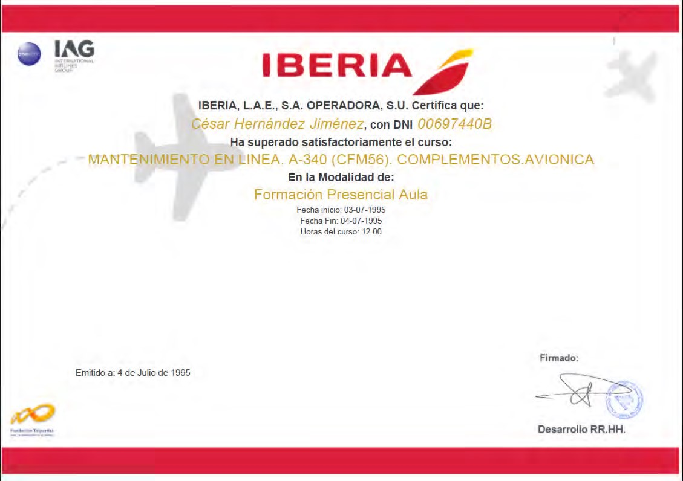
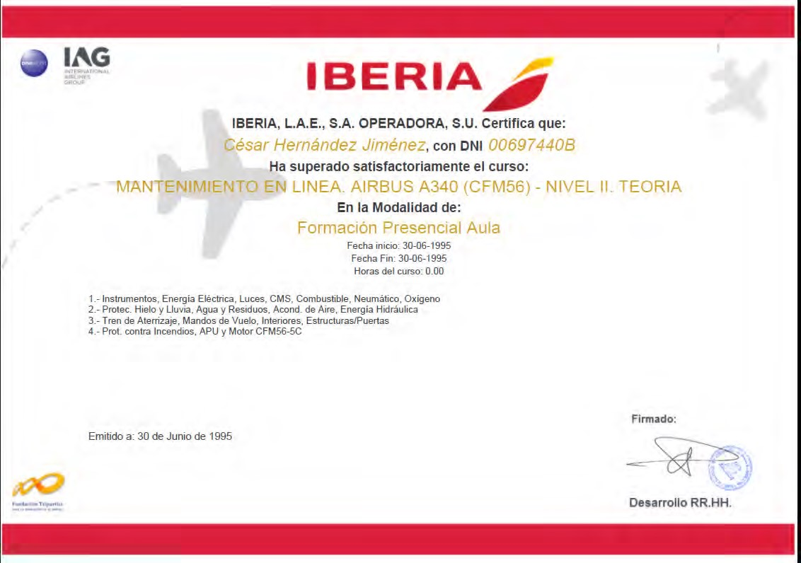
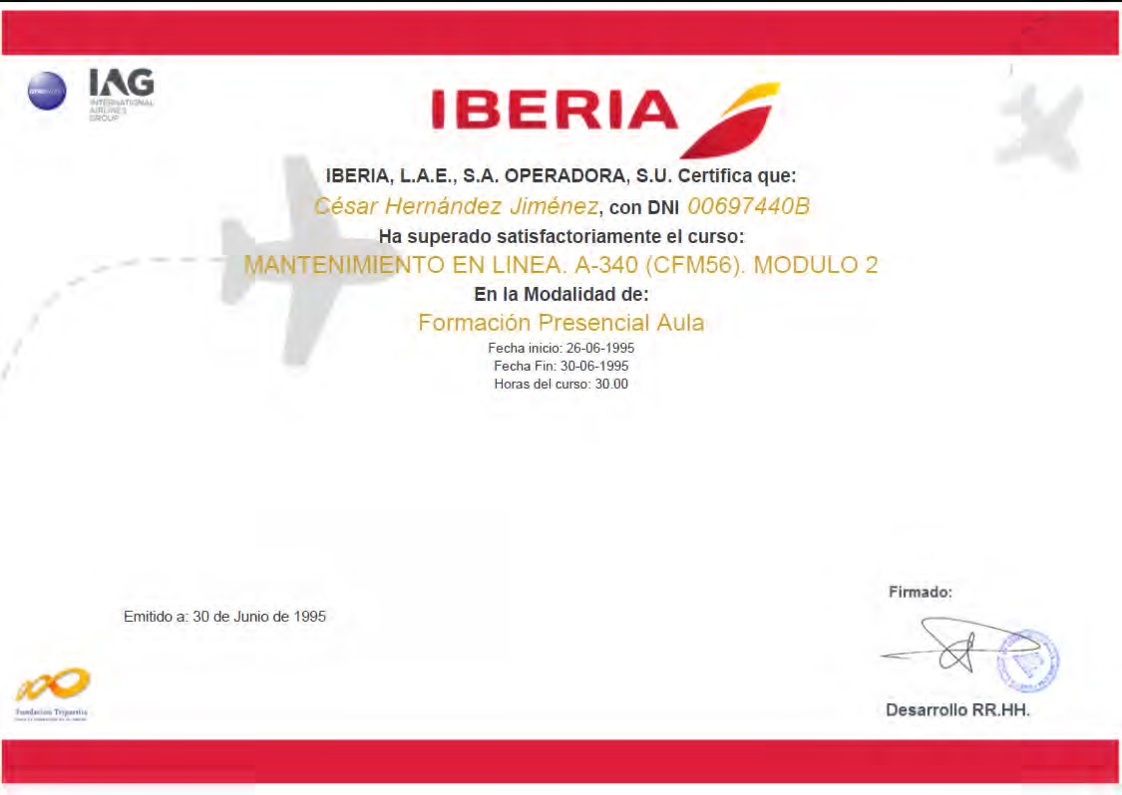
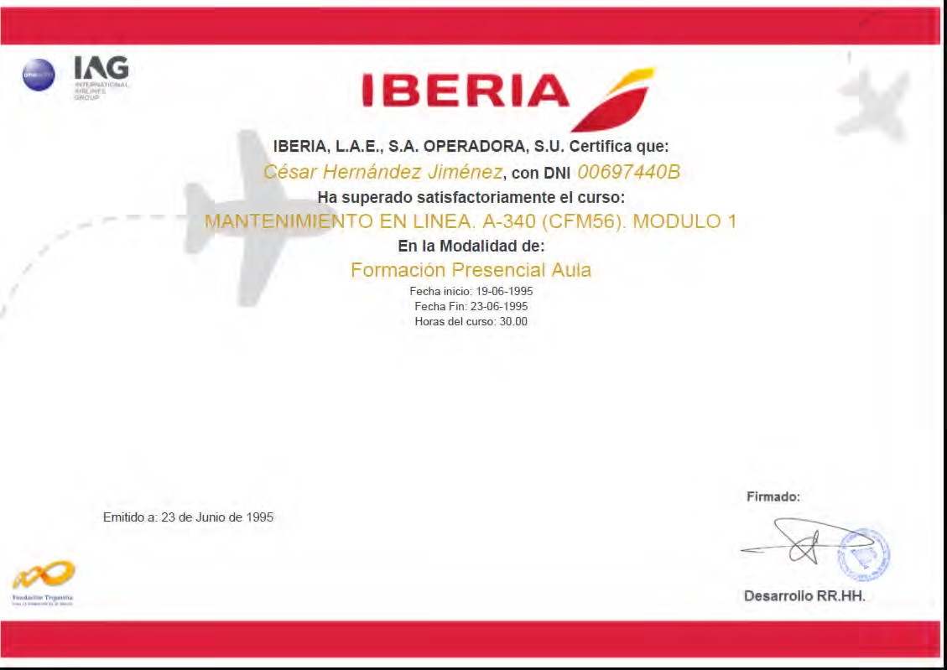
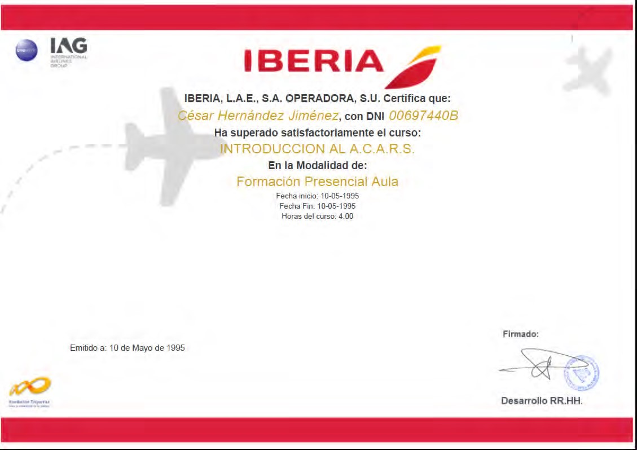
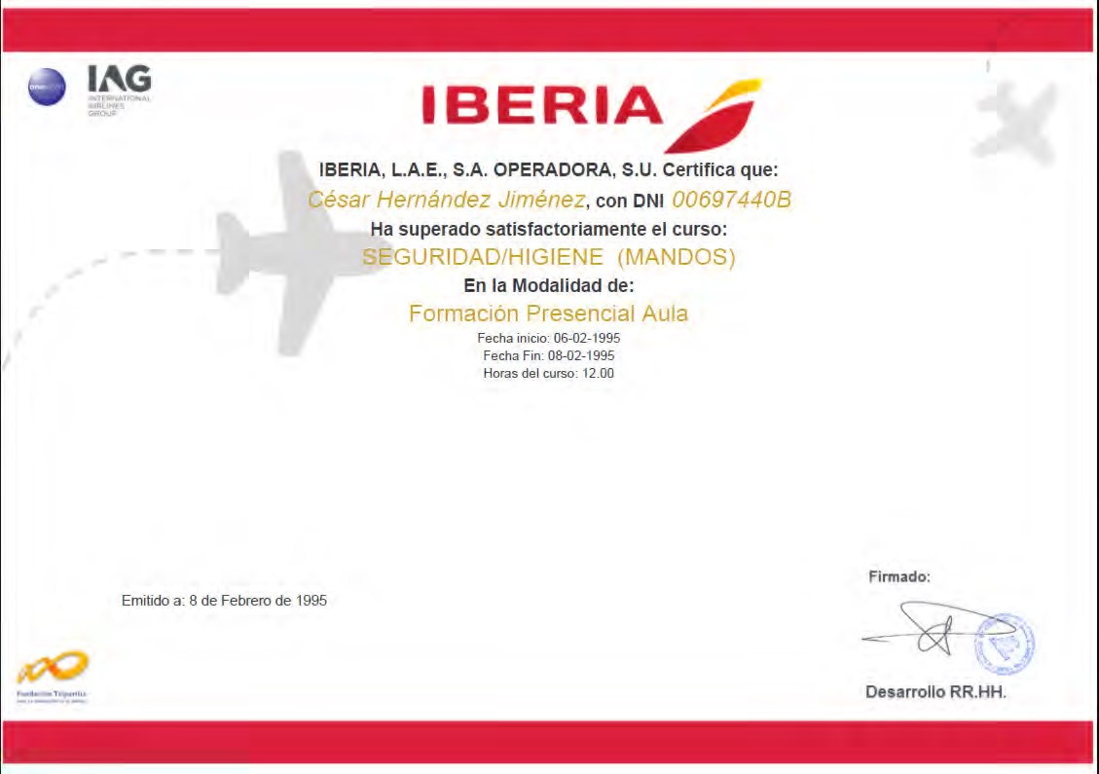
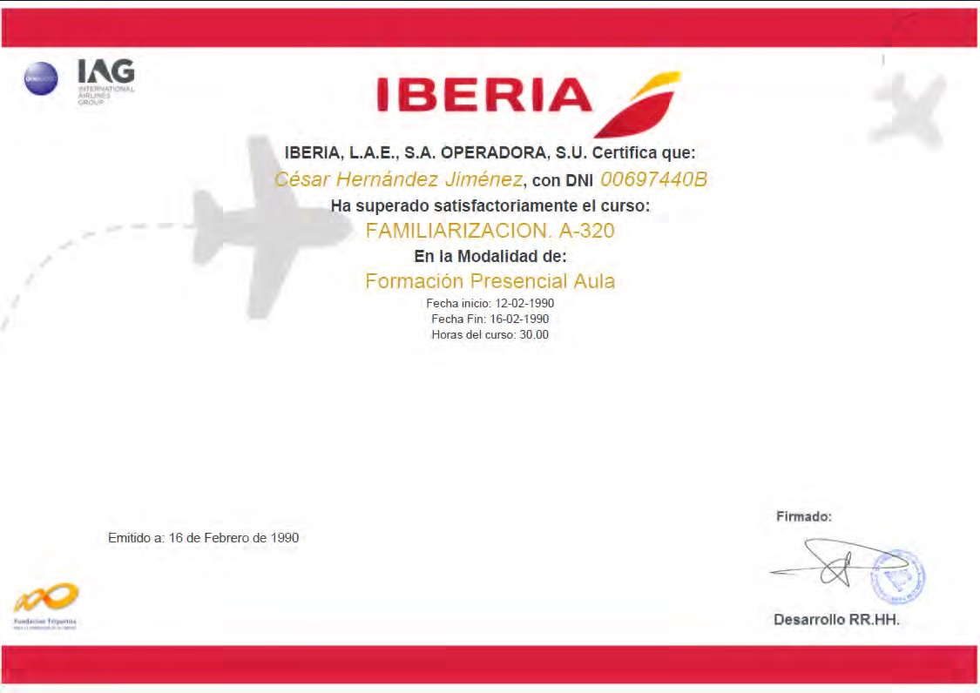
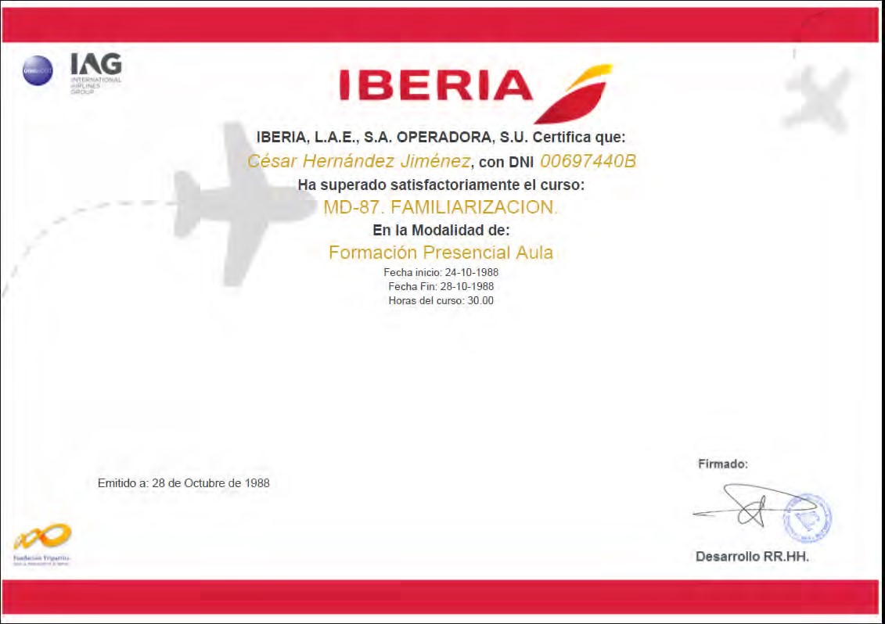
Cover page Patente Española nº 2304871
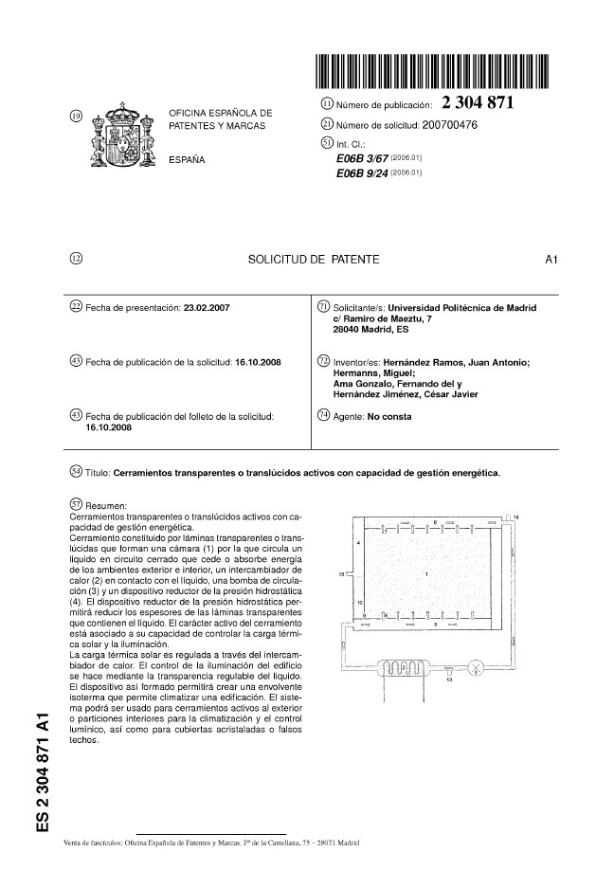
Cover page Patent Europe nº 2 123 856 A1
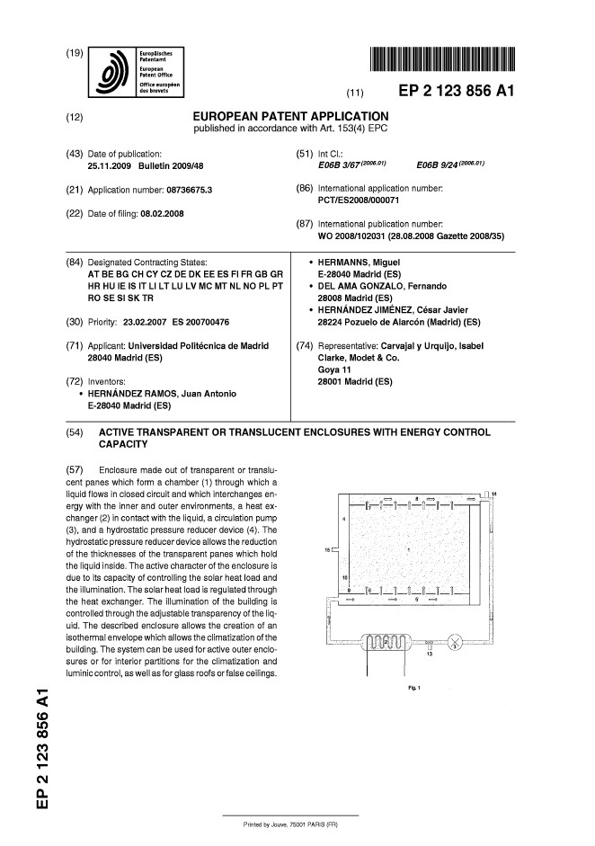
Cover page USA Patent nº 8 341 894 B2
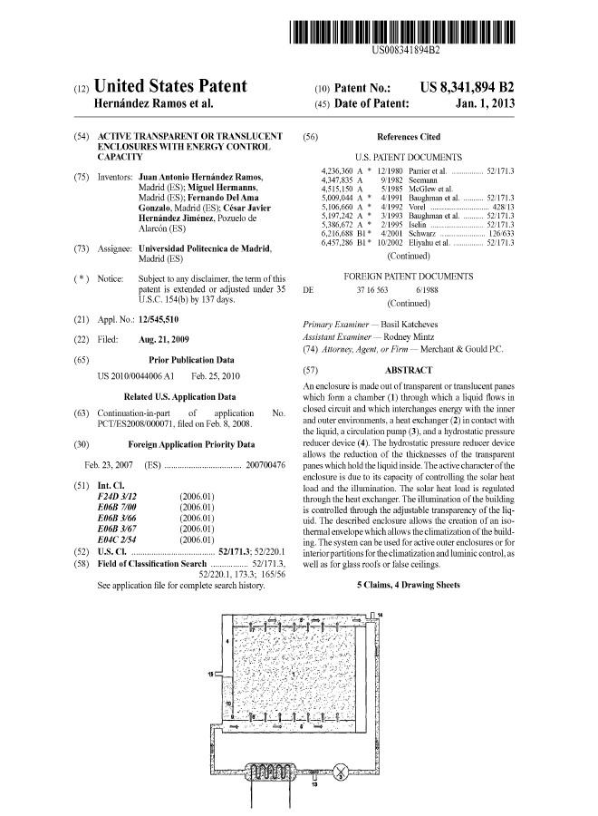
invitation MBA Luiss Business School

De: Roberto Paganin [mailto:rpaganin@globalaeroservice.it]
Enviado el: miércoles, 16 de mayo de 2012 17:11
Para: Hernández Jiménez, Cesar Javier [mailto: chernandezj@iberia.es] Asunto: Airline Operations & Maintenance Course

Dear Cesar,

Making reference to our last discussion in London, I’m here to request your participation to subject course which is one of those in the program of the Aviation MBA, organized by the LUISS Business School, Rome.
The LUISS Business School is a division of LUISS Guido Carli University that has a worldwide recognition as a knowledge hub for postgraduate studies.
LUISS Business School relies both on the experience of the University’s professors, and on the know-how of practitioners working in the fields of finance, consulting, and accounting.
The Aviation MBA program (www.mba.luiss.it/amba/) is an intensive course offered by Luiss Business School in Rome. The mission of the Aviation MBA is to provide candidates with a complete managerial education experience through management tools and techniques useful to compete in the international Aviation environment.
I will conduct the Airline Operations & Maintenance Course which will take a total of 20 hours divided in 5 lessons of 4 hours each.
One of the lesson will be dedicated to the Maintenance of Aircraft & Engines. I was thinking to include a business case with the title: The merging of Iberia Maintenance & BA Engineering. Your participation would be very helpful for presenting such business case, which shall take about 1,5 hour. The lesson is schedule for the next 17th of July, from 2:00 pm to 6:00 pm.
Please kindly confirm your participation.
Many thanks for your kind attention and consideration. Looking forward to hearing from you.

Best Regards,

Roberto Paganin
Principal
Tel. +39 06 5651853 Mob. +39 335 7811073 rpaganin@globalaeroservice.it
www.globalaeroservice.it
Catálogo Comercial Intelliglass

Desarrollado en Abril de 2010 para la FERIA VETECO.
